Estimating and Recording Behaviours/Strategies
Student doesn’t estimate or shows anxiety about inaccurate estimates. | Student makes very large or very small estimates. | When asked, “How long is your object?” student replies with only a number.  “It is 6 long.” | Student estimates the lengths of all objects, accurately measures them, and includes the unit with the counts.
Observations/Documentation
Measuring Length Behaviours/Strategies
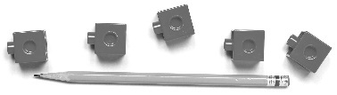  Student leaves gaps or overlaps when trying to line up the cubes end-to-end. | Student uses cubes to measure but does not line up the base of the first cube with the end of the object he or she is measuring.  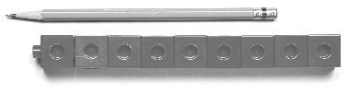 | 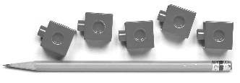  Student aligns the base of the first cube with the end of the object being measured, and there are minimal gaps. | 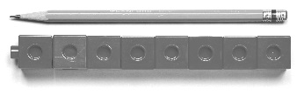  Student links cubes and aligns the base of the train with the end of the object being measured.
Observations/Documentation

