Comparing Objects Behaviours/Strategies
Student chooses unsuitable objects to make a comparison.  “I will use the eraser and the pencil to compare capacity.” | Student attempts to compare objects by length but does not line them up along a baseline. | 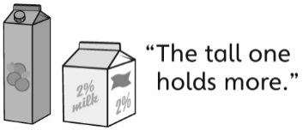  Student thinks a larger object has a greater mass or a taller object has a greater capacity.
Observations/Documentation
Student successfully chooses a tool to compare mass or capacity but does not understand how to use it. | Student correctly chooses and compares objects and checks the comparison but has difficulty using measurement language to describe the comparison. | Student correctly chooses and compares objects, checks the comparison, then describes the comparison using measurement language.
Observations/Documentation

