**Necklace/Bracelet Template**

**Master 36a**

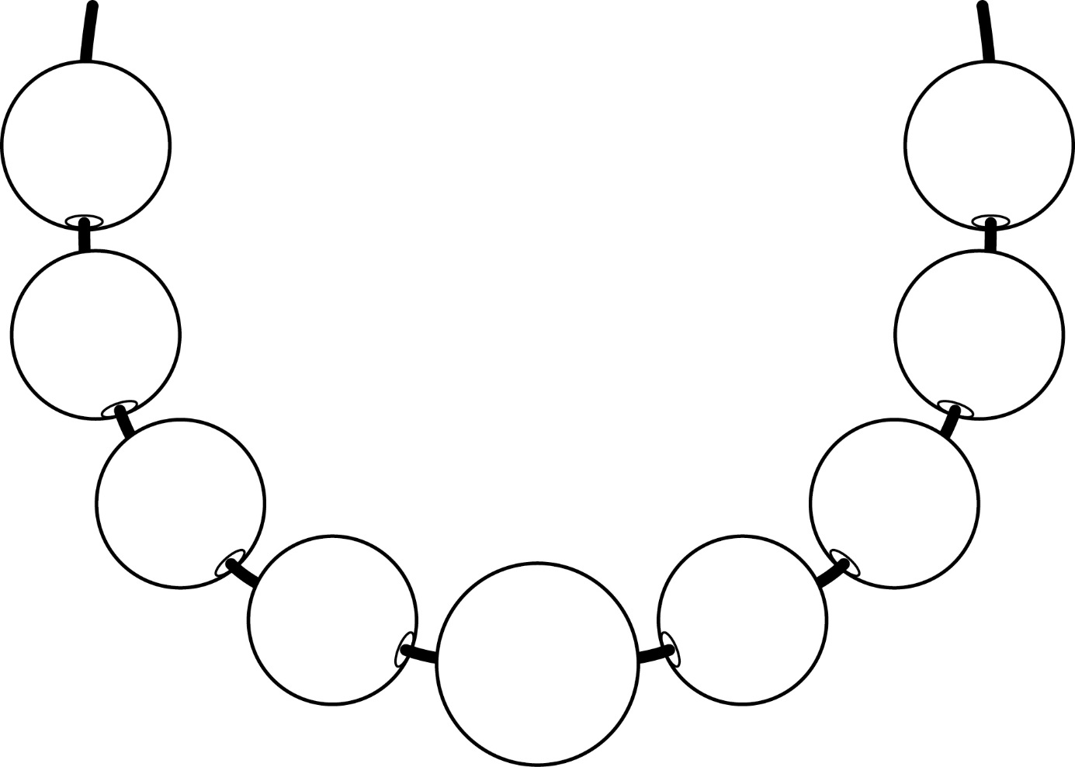

**Necklace/Bracelet Template**

**Master 36b**

