**Made with Solids Cards**

**Master 29a**

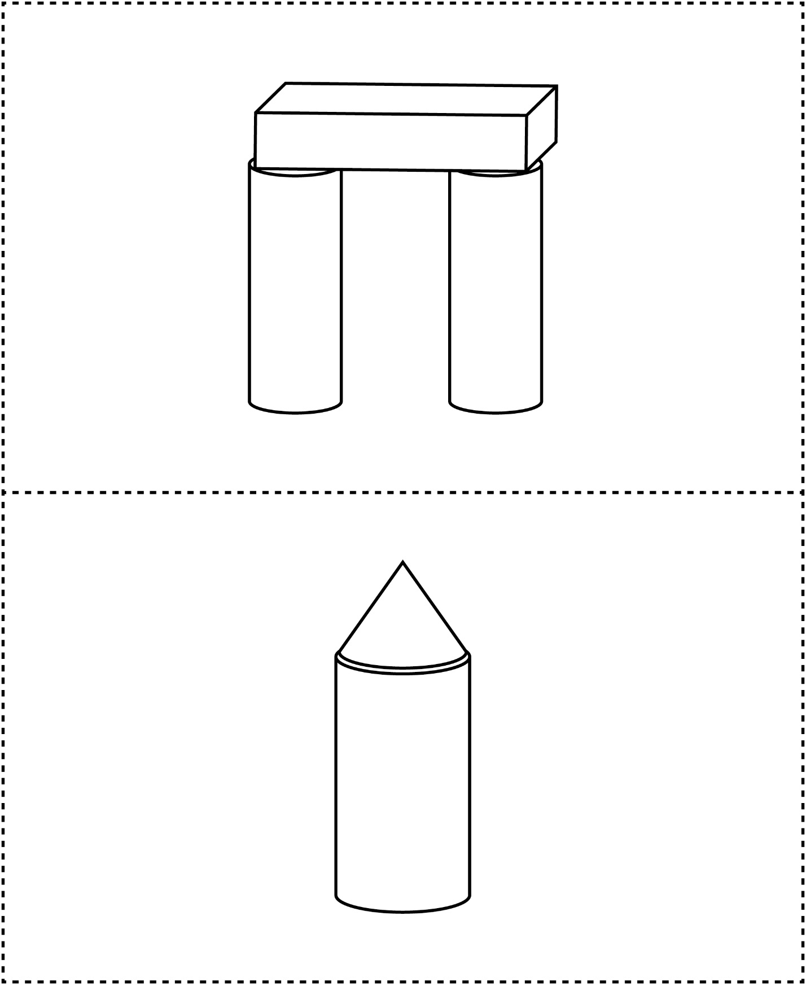



**Made with Solids Cards**

**Master 29b**

