**Shape Outline Cards**

**Master 28a**

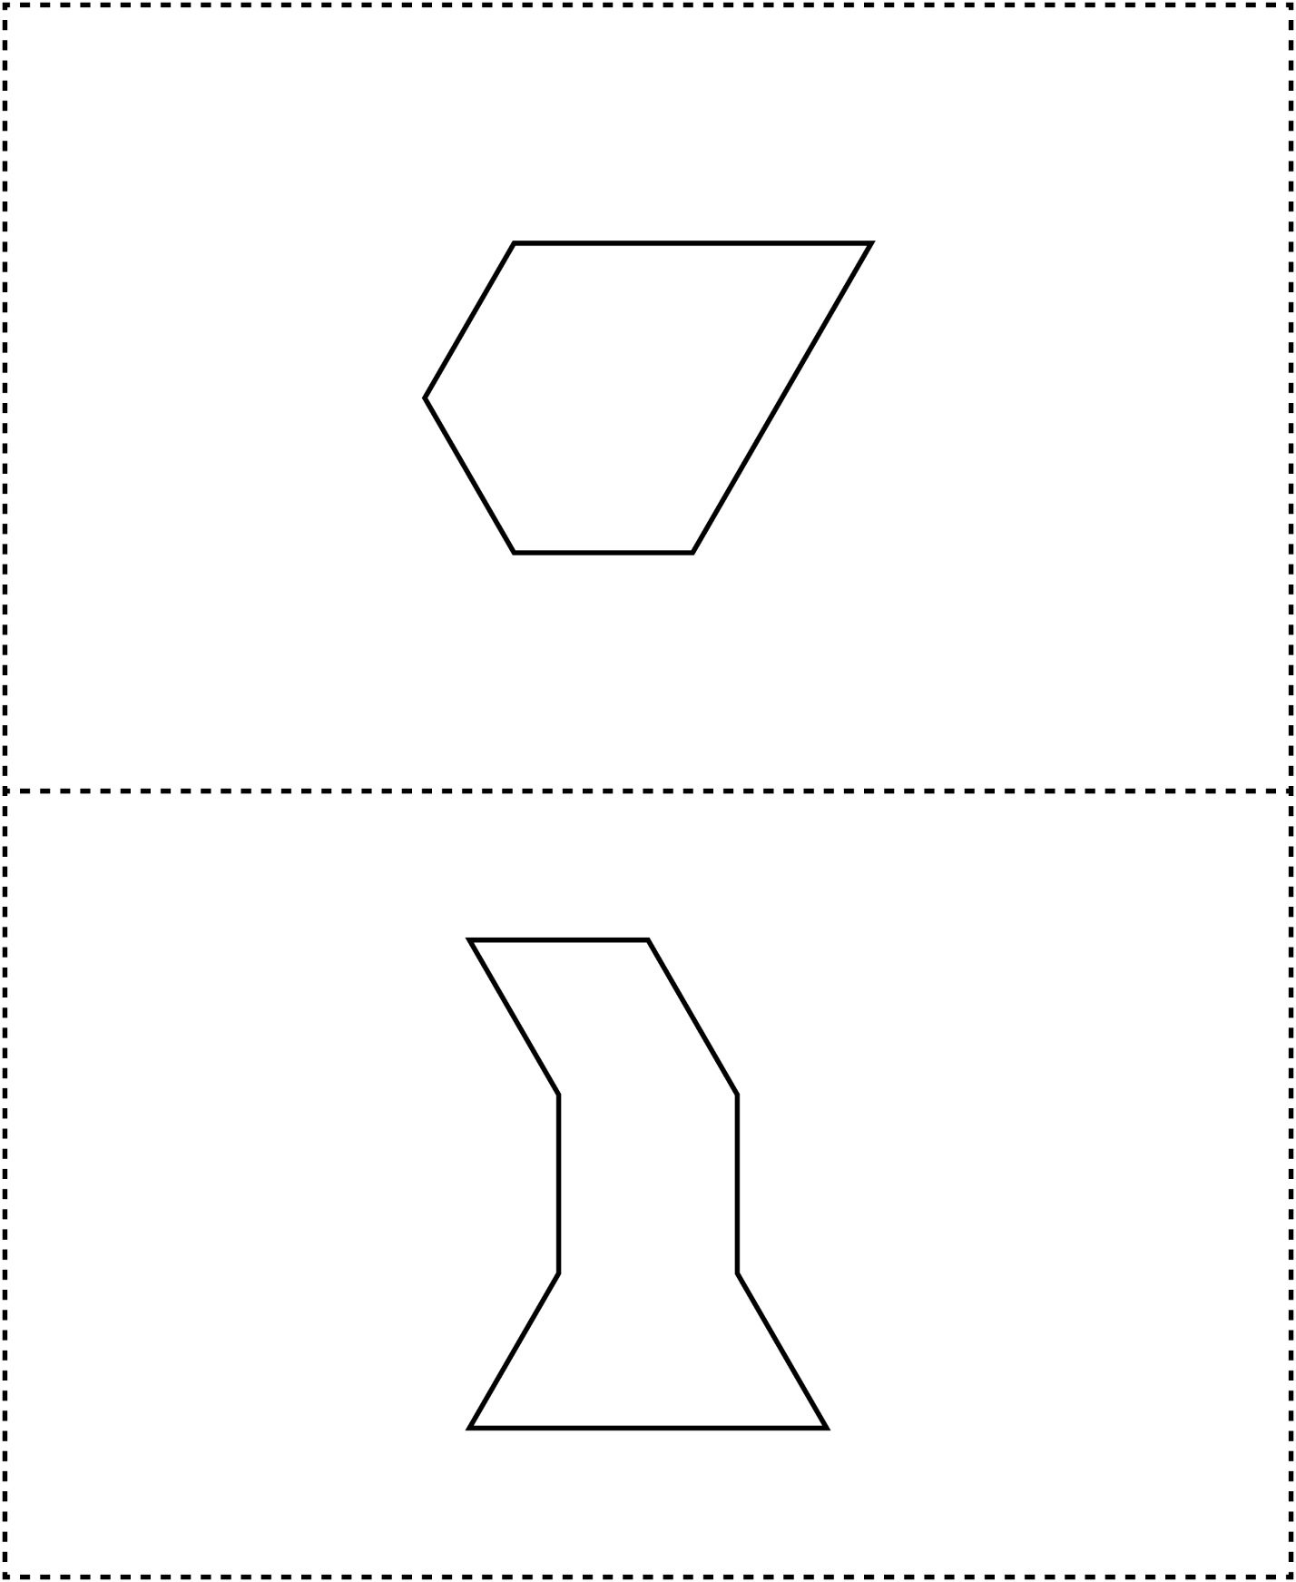



**Shape Outline Cards**

**Master 28b**

