Making Designs Behaviours/Strategies
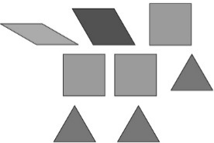  Student makes a design or picture with no blocks touching. | 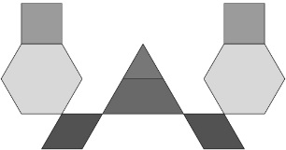  Student makes a design or picture where some blocks are touching only at vertices. | 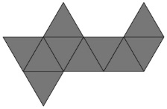  \Student makes a design or picture using only one type of block.
Observations/Documentation
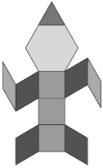  Student makes a design or picture  where blocks match on at least  one side, but has difficulty  describing the design. | 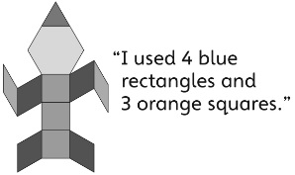  Student calls the blue rhombuses rectangles when describing the picture or design. | Student makes a picture or design where blocks match on at least one side, and describes it using geometric and spatial language.
Observations/Documentation

