Sorting Solids Behaviours/Strategies
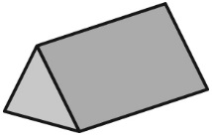  Student is not able to identify shapes within solids. | Student recognizes some triangles but doesn’t recognize a triangle when it doesn’t match her or his mental image of a triangle.  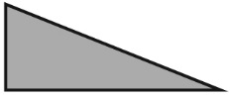 | Student can identify some rectangles but thinks these shapes are not rectangles because they are “too long” or “too fat.” | 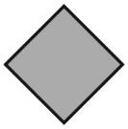  Student recognizes some shapes but doesn’t recognize a shape when it is oriented differently.
Observations/Documentation
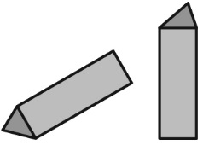  Student identifies some faces but doesn’t rotate the solid to see the different faces (shapes). | Student focuses on one shape and doesn’t realize that the faces of a solid can be more than one shape. | Student can sort a solid but only in one way.  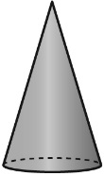  “It has a face that is a circle!  I can’t sort it another way.” | Student can sort solids in more than one way.  “I can sort the rectangular prism in two ways. It has 6 faces and it has a rectangular face.”
Observations/Documentation

