**Object Pictures**

**Master 115a**

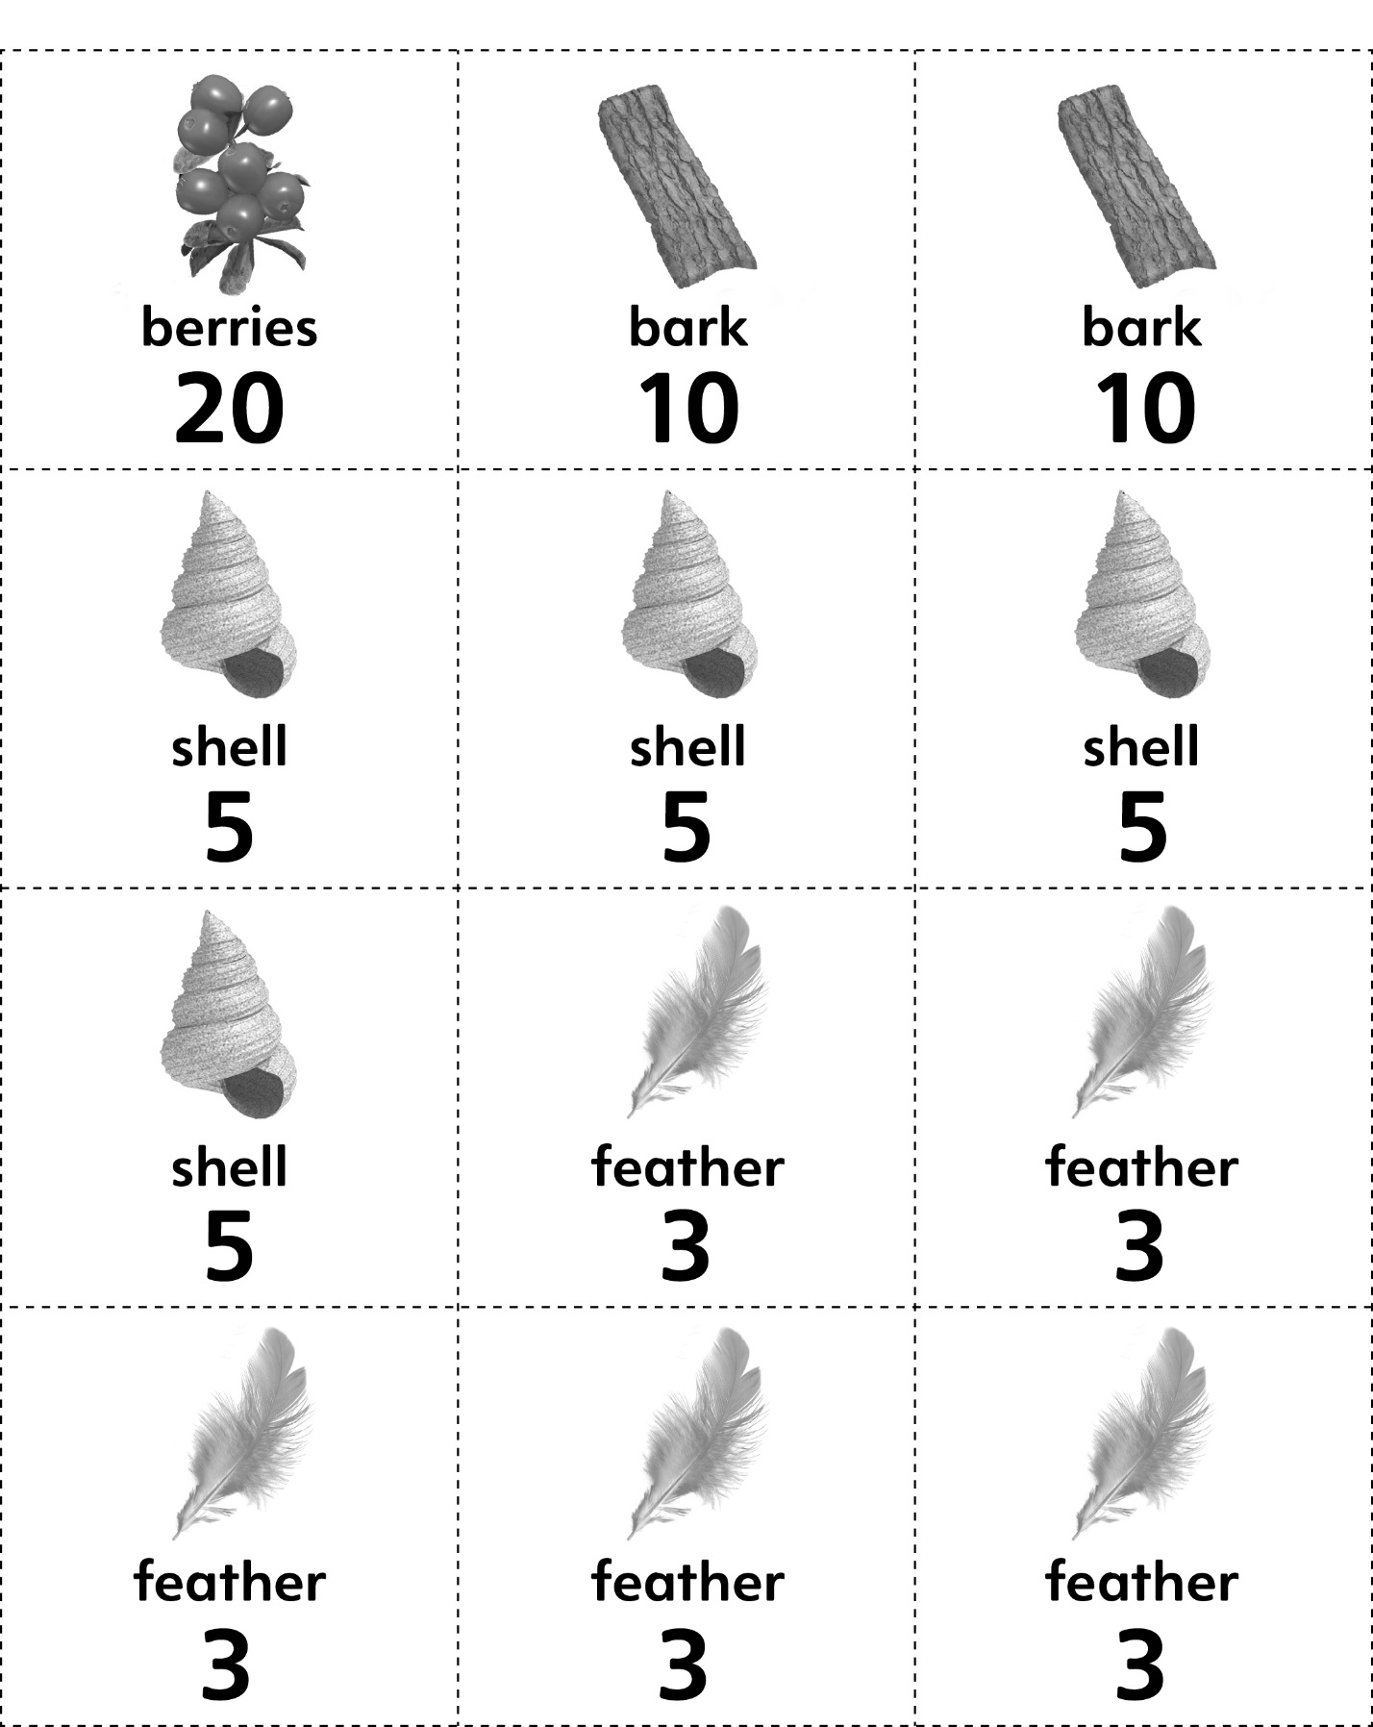



**Object Pictures**

**Master 115b**



