Skip-Counting Backward Behaviours/Strategies
Student sorts coins and bills, but has difficulty identifying their names.  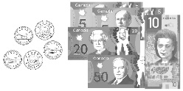  “I’m not sure what each  coin/bill is called.” | Student sorts coins and bills by colour and name, but cannot identify their values.  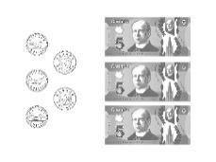  “I know these are all blue bills, but I am not sure what they are worth.” | Student knows the value of loonies, toonies and bills, but struggles to compare their values.  “This is a toonie and this is a loonie. I don’t know which one is worth more.” | Student successfully identifies names and values of coins and bills, and compares them in different ways.  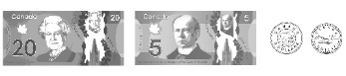  “I ordered the collection from greatest to least value.”
Observations/Documentation

