Identifying the Values of Coins Behaviours/Strategies
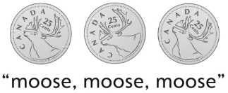  Student identifies coins by their size or physical attributes. | Student identifies coins but cannot call them by name. | Student knows the names of coins but cannot remember their values.
Observations/Documentation
Student is able to match a value to a physical coin but cannot match a value to the name of a coin. | Student can match a value to a coin but cannot compare the values of different coins. | Student knows the names and values of the coins and can compare pairs of coins with ease.
Observations/Documentation

