Picture Problems
Master 108

Story Problems Answers
15 were on the .
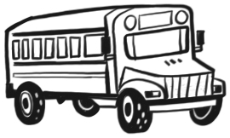
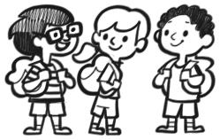
16 got on.
How many are now
on the ?
33 were in the .
Some hopped away.
Now 25 are in the .
How many hopped away?
43 were in a .
17 fell off the .
How many were left in
the ?

