**Math in Pictures**

**Master 102a**

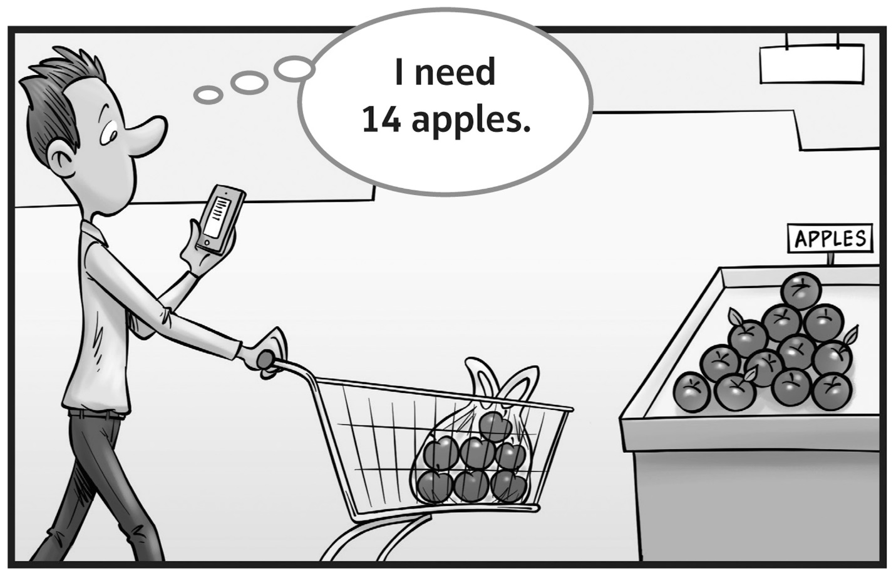

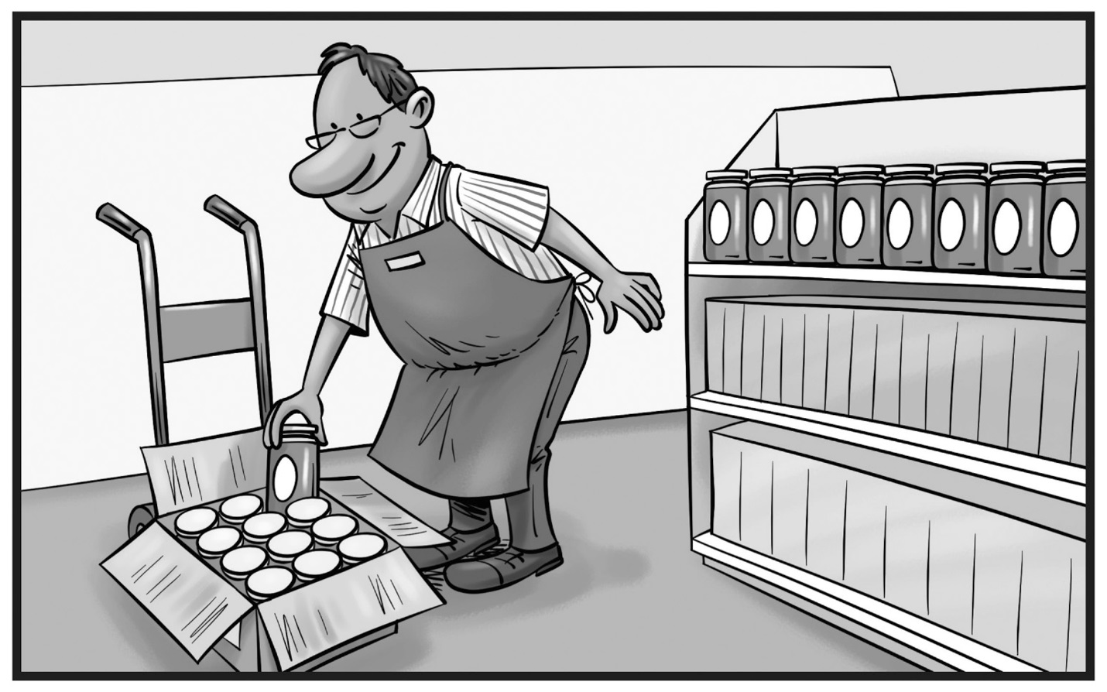

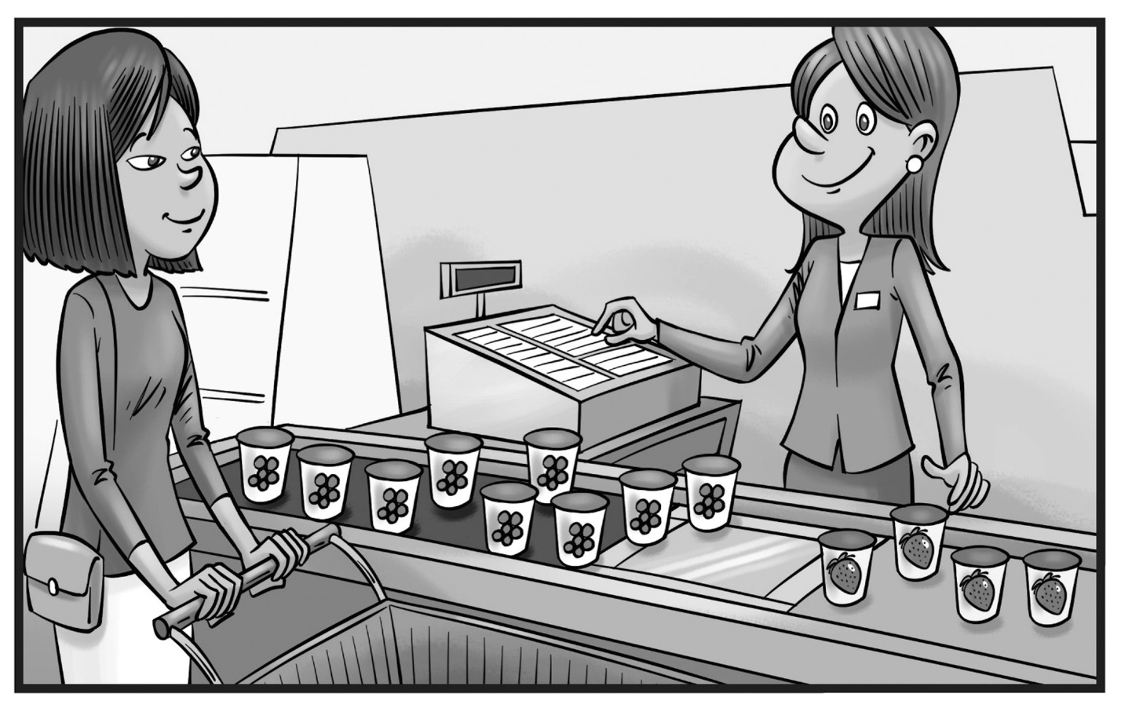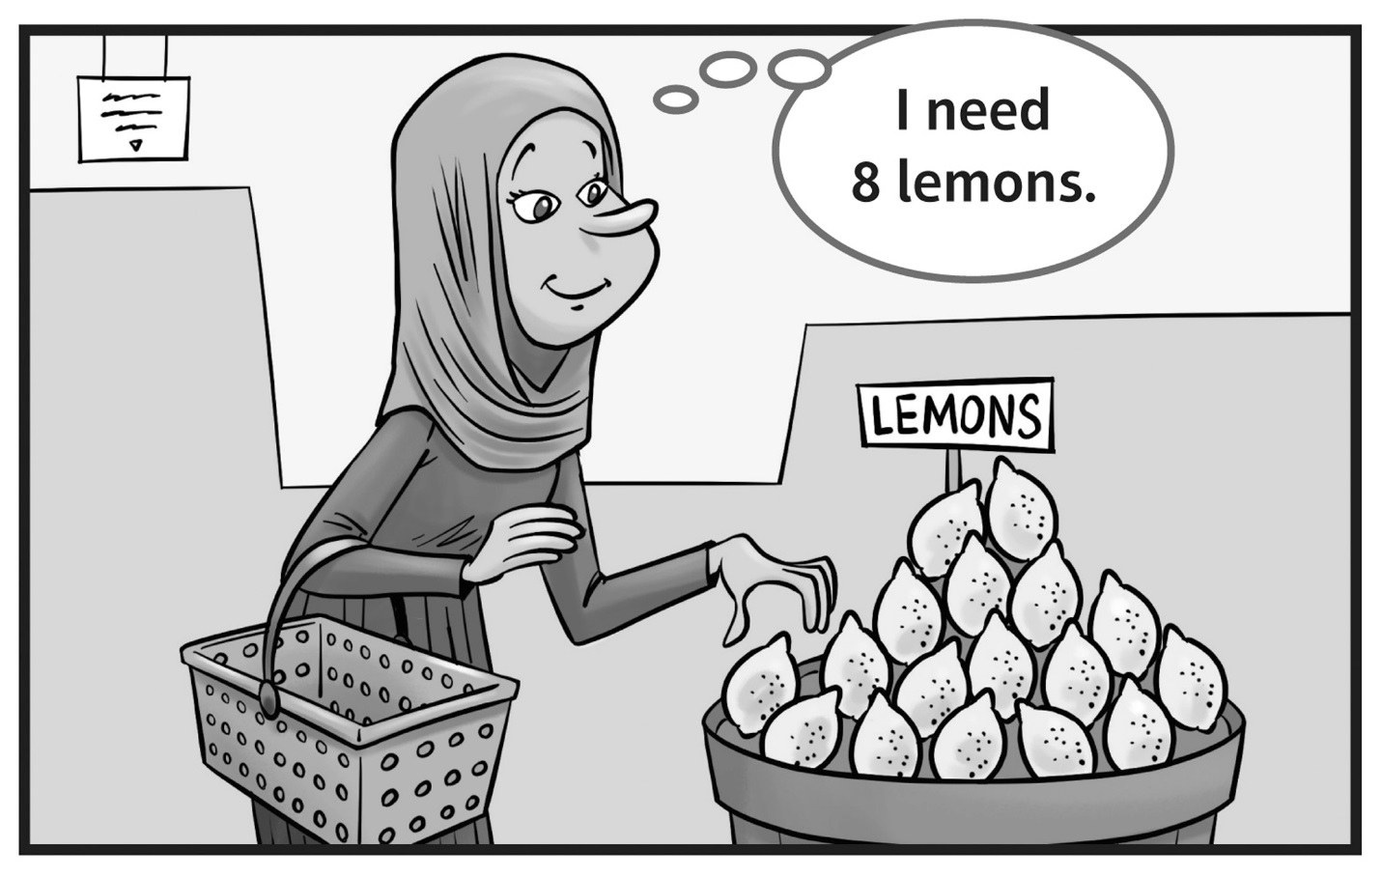**Math in Pictures**

**Master 102b**

**Math in Pictures**

**Master 102c**

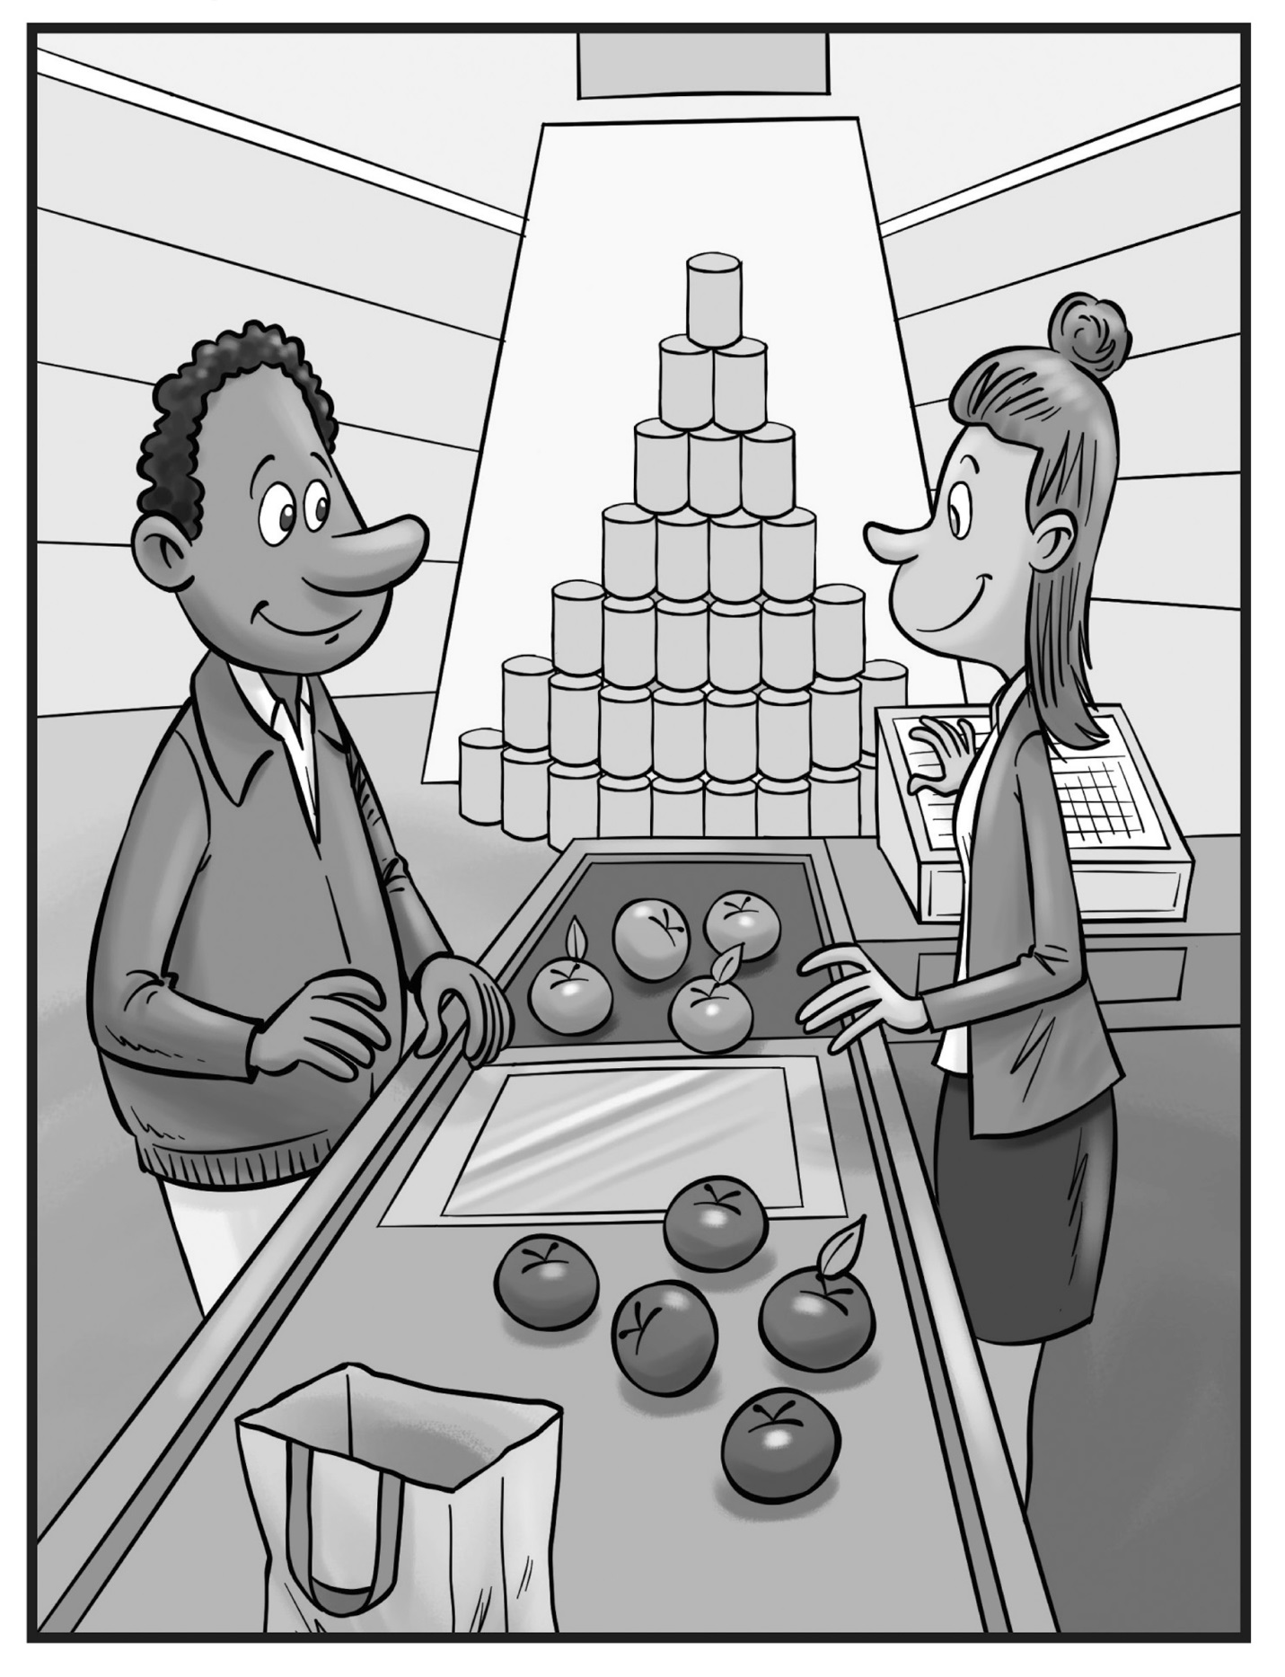

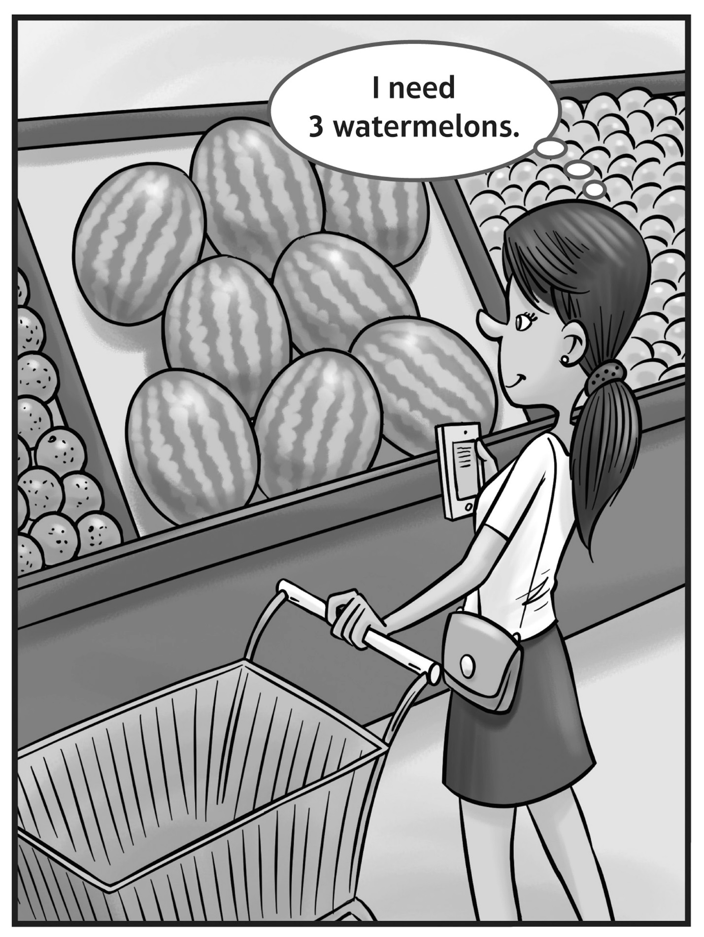**Math in Pictures**

**Master 102d**

**Math in Pictures   
  
**

**Master 102e**

**Math in Pictures   
  
**

**Master 102f**

**Math in Pictures   
  
**

**Master 102g**

**Math in Pictures   
  
**

**Master 102h**