**Domino Cards**

**Master 99a**

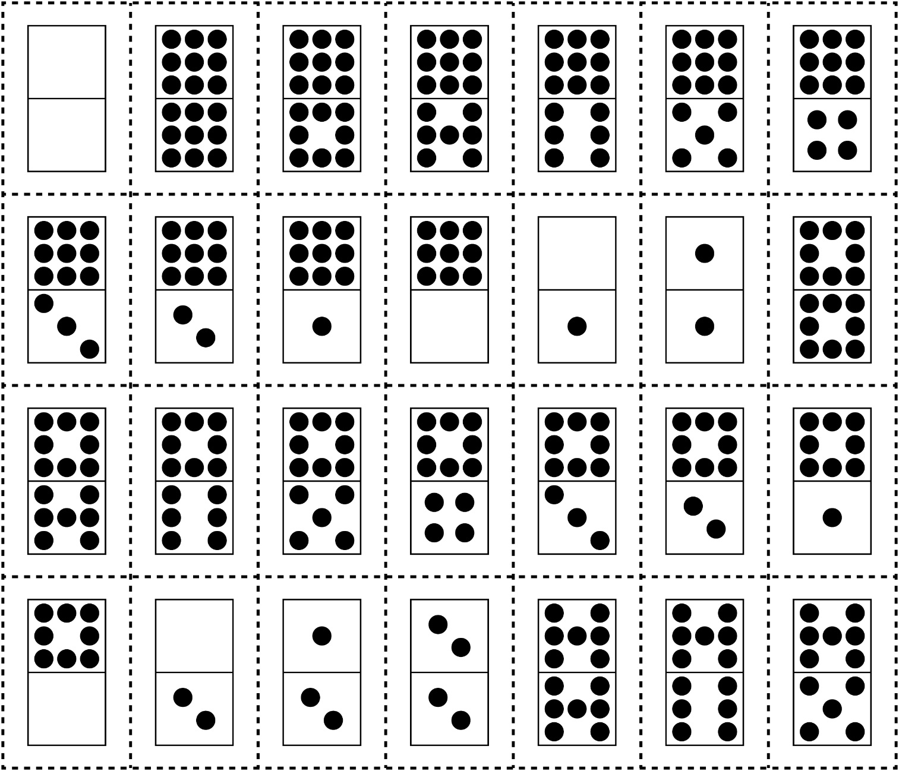

**Domino Cards**

**Master 99b**

