**Number Sentences**

**Master 97a**

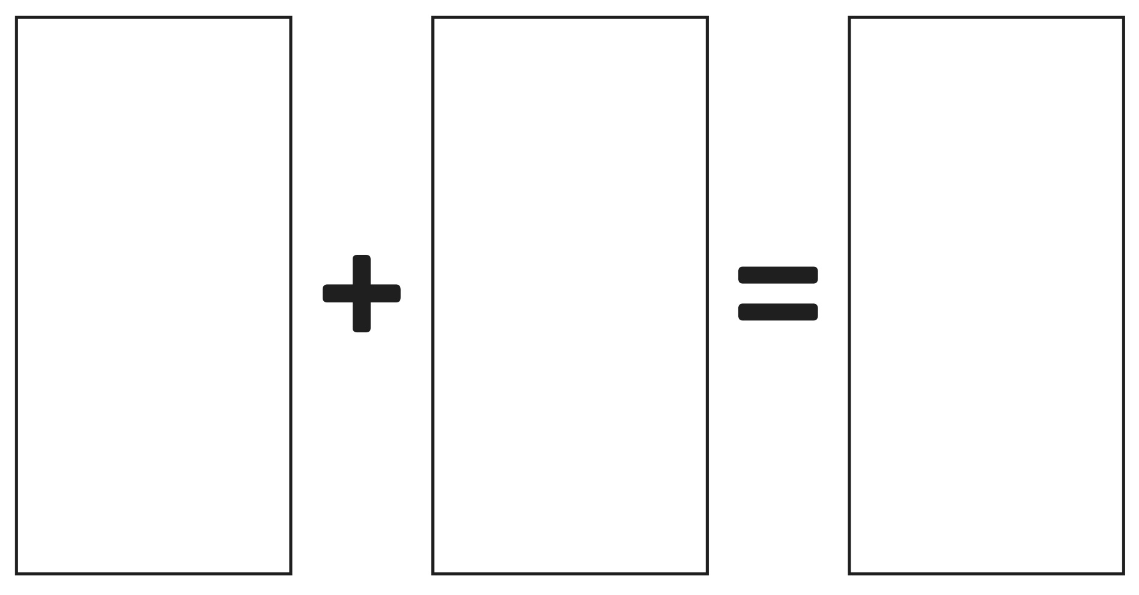

**Number Sentences**

**Master 97b**

