Conceptual Understanding of Addition Behaviours/Strategies
Student does not say one number word for each counter counted, or says number word in between “touches.” | Student mixes up the number sequence when counting on.  “8, 9, 11” | Student counts on but loses track of the number counted on.  “6, 7, 8, 9.  Did I count on 2?” | Student always counts on from the first set.  2 + 8  “3, 4, 5, 6, 7, 8, 9, 10”  8 + 2  “9, 10”
Observations/Documentation
Adding Numbers Behaviours/Strategies
Student adds the two numbers using counters and counts three times. | 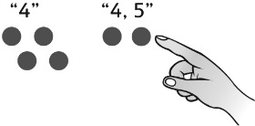  When counting on, student begins the count of the second set with the last number in the first set. | 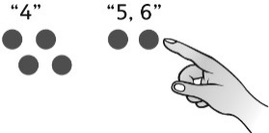  Student uses counters to count on correctly. | Student uses efficient addition strategies (e.g., 1 and 2 more, doubles, making ten, visualizing a number line) to find the sums.
Observations/Documentation

