Comparing and Ordering Unit Fractions Behaviours/Strategies
Student divides into two parts but parts are not equal. | Student can divide in half but struggles to partition into thirds, sixths, and eighths.  “How do I make 4 equal parts?” | Student can divide into equal parts but struggles to name the unit fraction.  “I don’t know what each part is called.”
Observations/Documentation
Student divides into equal parts and names unit fraction but doesn’t realize that the more parts, the smaller the part. | Student compares tow parts but struggles to order many parts.  “One-half is bigger than one-fourth.” | Student successfully compares and orders unit fractions.  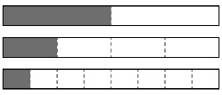  “From biggest to smallest: one-half,  one-fourth, one-eighth.”
Observations/Documentation

