Partitioning and Describing Parts of a Whole Behaviours/Strategies
Student does not recognize and describe  one-half.  “These both show half.” | 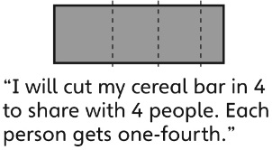  Student partitions a whole into the correct number of parts, but the parts are not all equal. | Student partitions a whole into two equal parts, but has difficulty dividing a whole into more equal parts.
Observations/Documentation
Student partitions a whole into equal parts, but has difficulty with fraction words.  “There are 3  small halves.” | Student partitions a whole into equal parts, but doesn’t consider the whole when discussing fractions.  “One-half is always bigger than one-fourth.” | Student partitions wholes into equal parts and can accurately describe the parts using fractional names.
Observations/Documentation

