**Coin Cards**

**Master 53a**

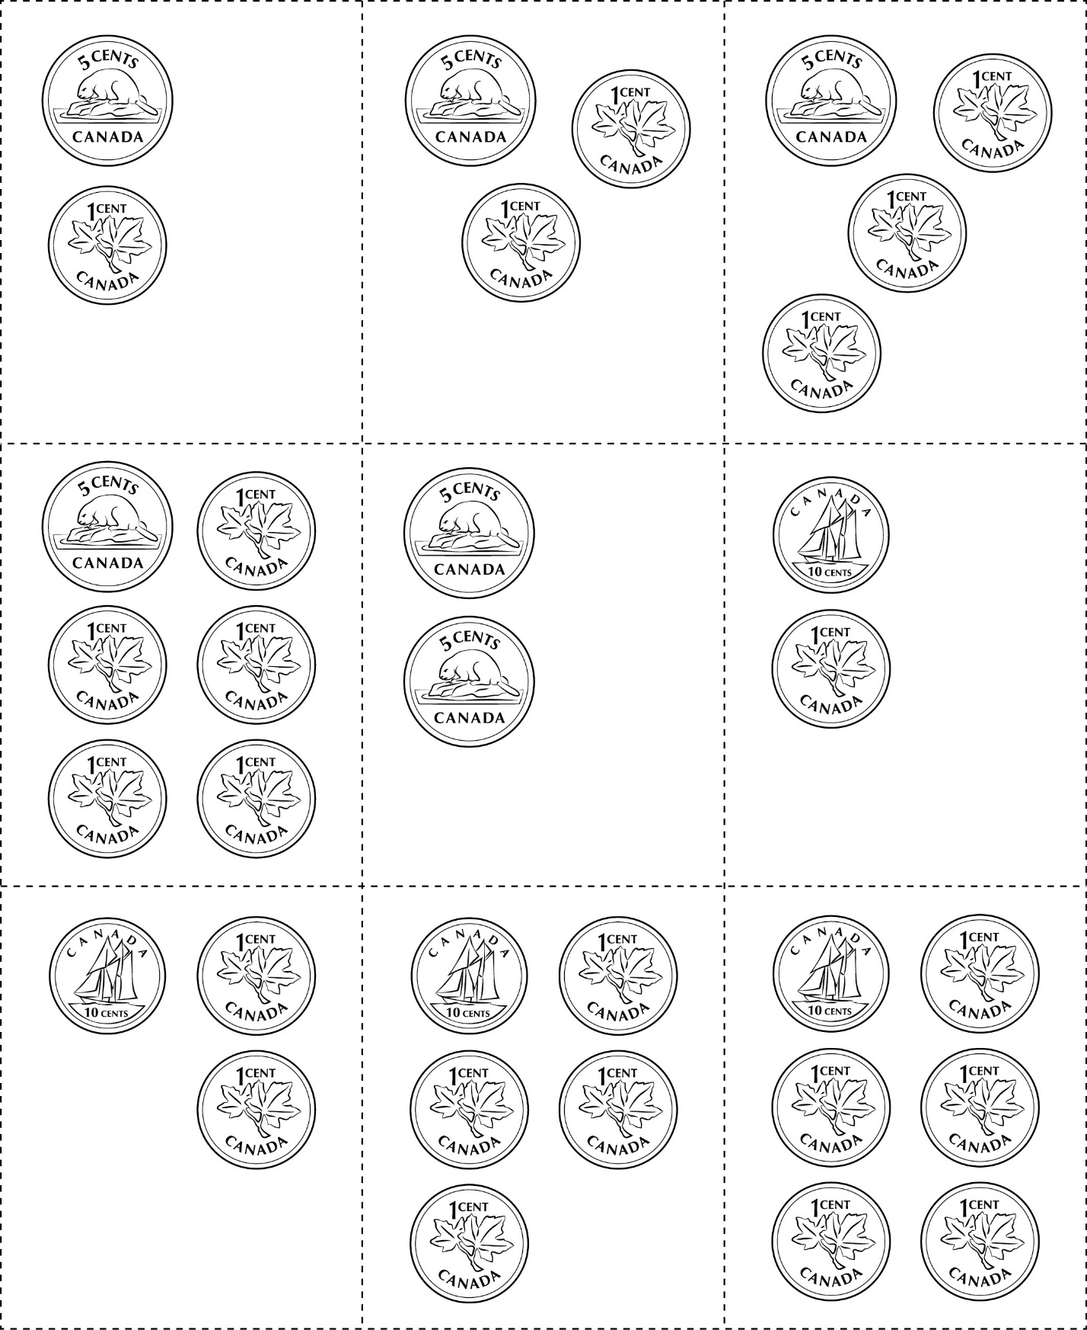



**Coin Cards**

**Master 53b**

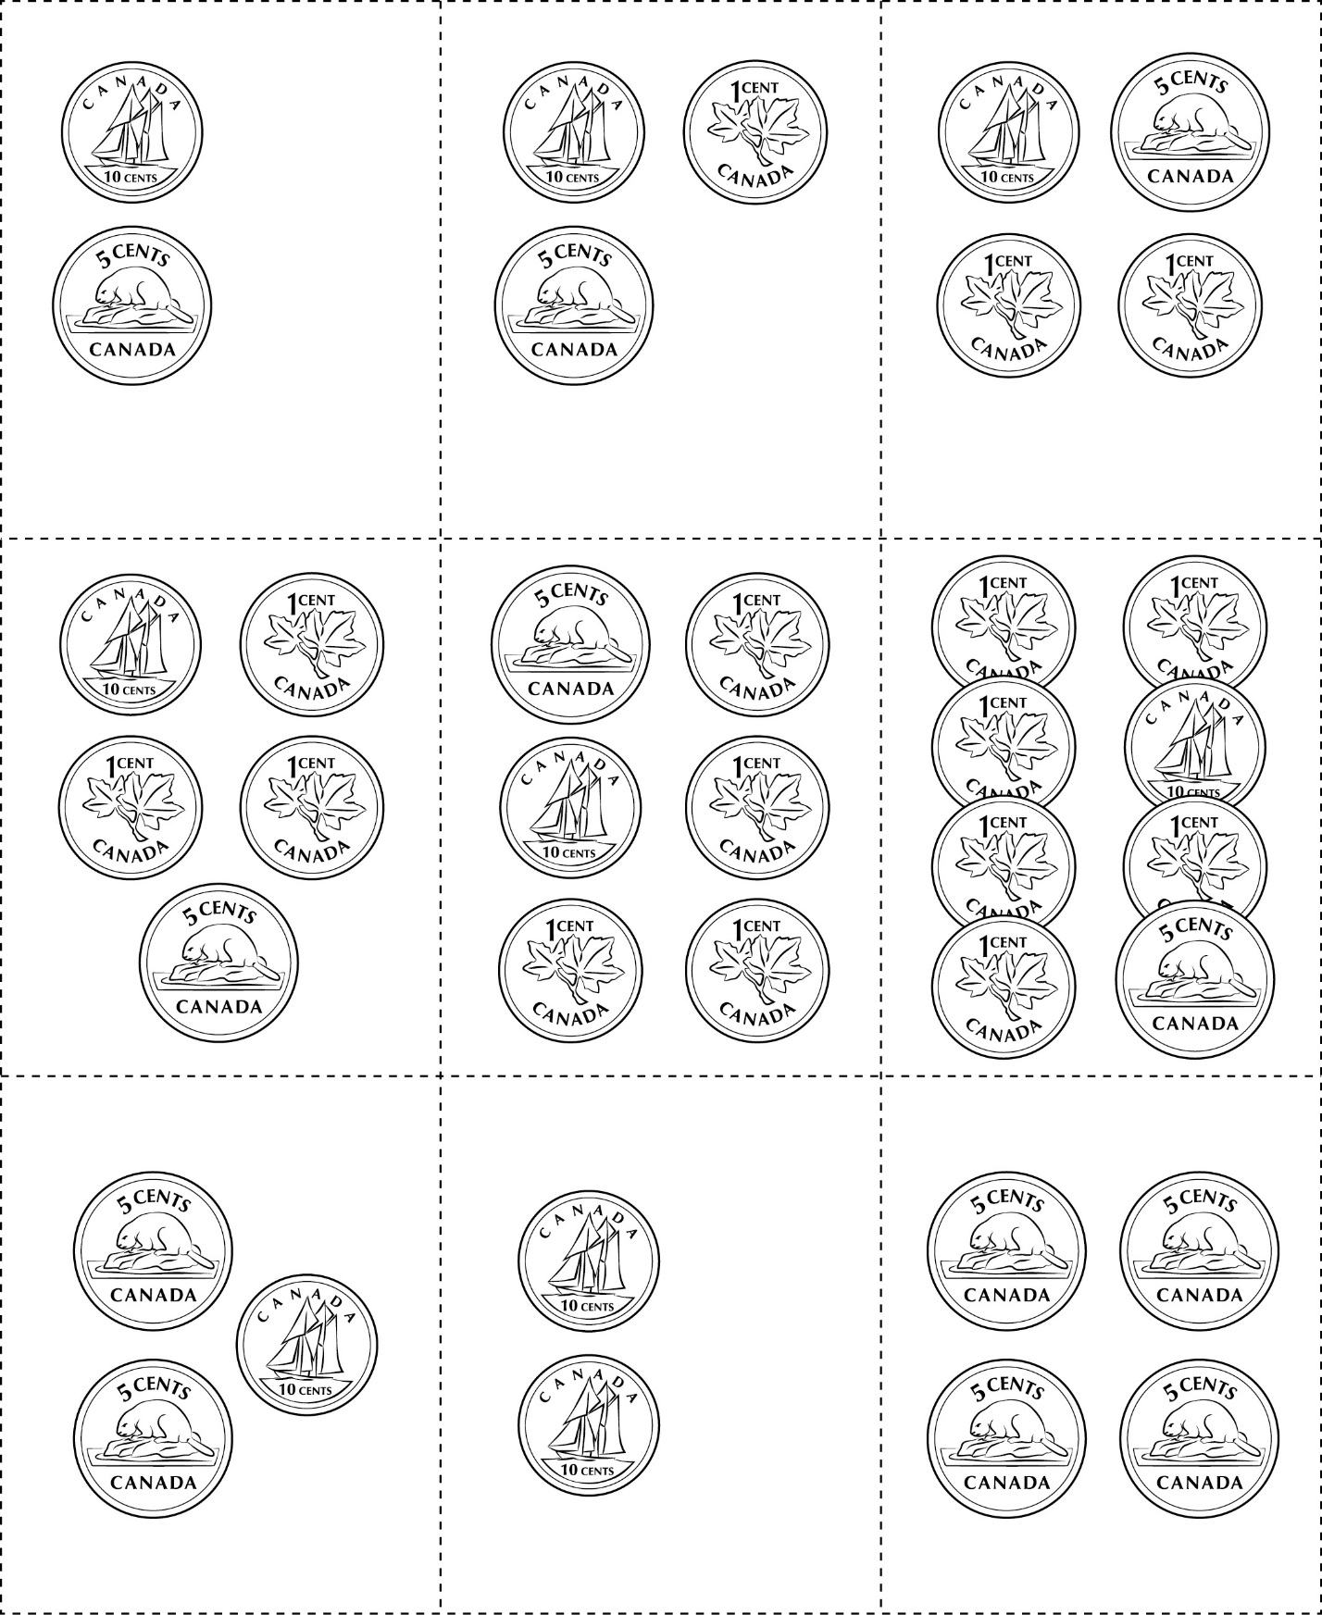

**Coin Cards**

**Master 53c**

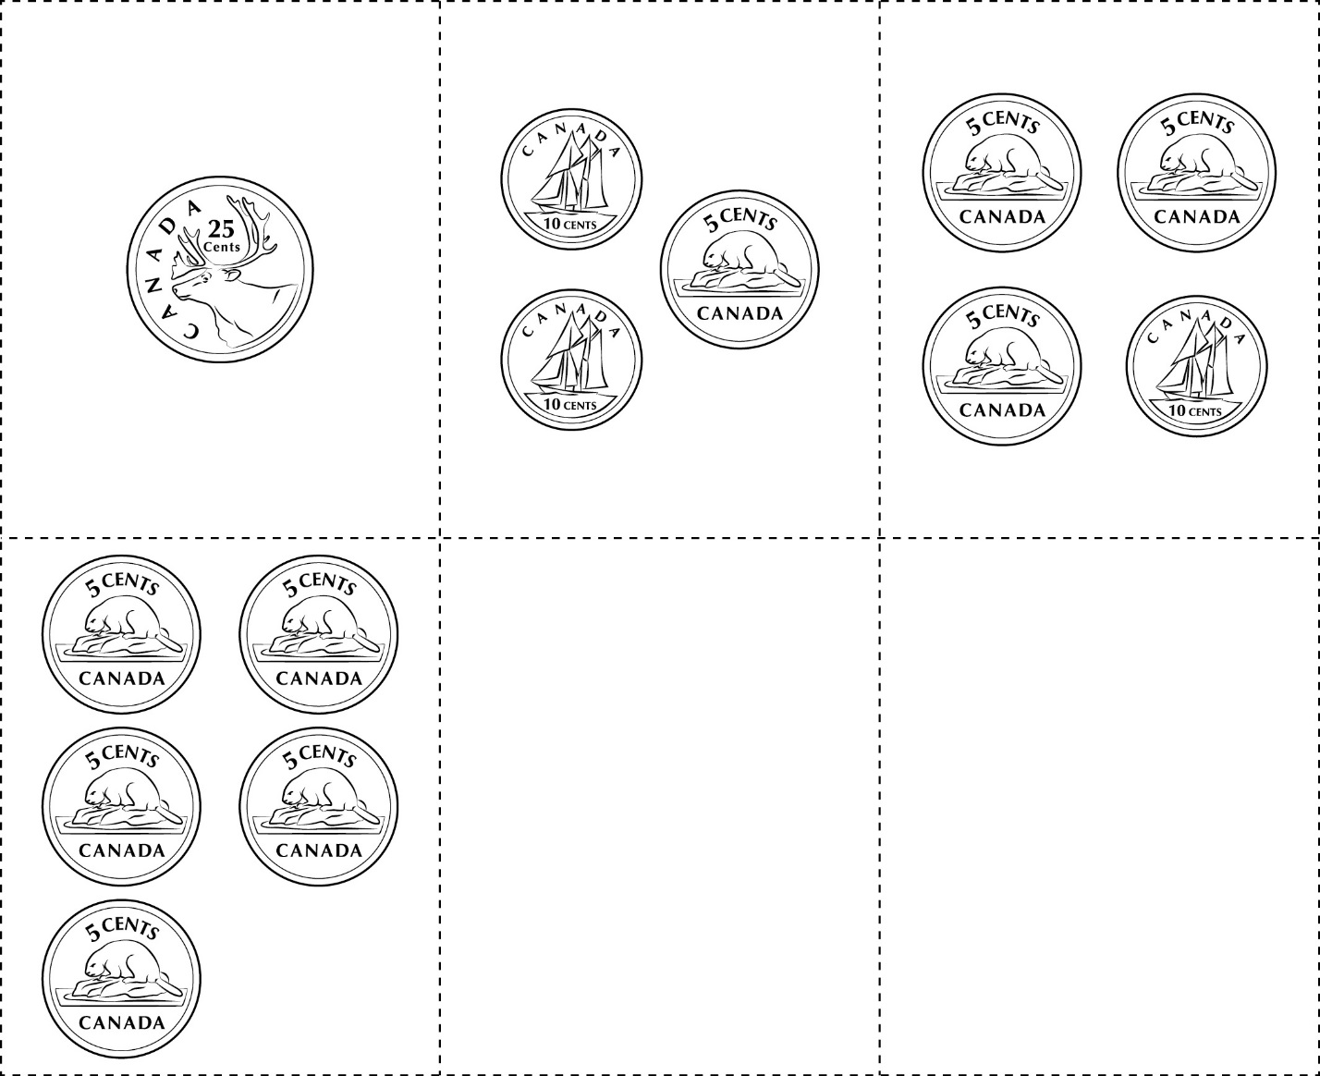

|  |  |  |
| --- | --- | --- |
|  |  |  |

**Coin Cards**

**Master 53d**



|  |  |  |
| --- | --- | --- |
|  |  |  |
|  |  |  |
|  |  |  |

**Coin Cards**

**Master 53e**

(for Extension)



|  |  |  |
| --- | --- | --- |
|  |  |  |
|  |  |  |
|  |  |  |

**Coin Cards**

**Master 53f**

(for Extension)



|  |  |  |
| --- | --- | --- |
|  |  |  |
|  |  |  |
|  |  |  |