Skip-Counting Behaviours/Strategies
Student mixes up or does not know the number to skip-count by. | Student mixes up the numbers in the skip-counting sequence.  “2, 4, 8, 6, 10, …” | 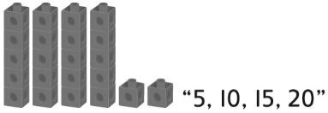  Student skip-counts but does not include the leftovers in the total.
Observations/Documentation
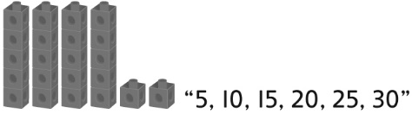  Student continues to skip-count by the same number to count the cubes in the dump truck. | Student skip-counts but doesn’t realize that the total number of cubes when 10-cube towers are made will be the same when 5-cube towers are made. | 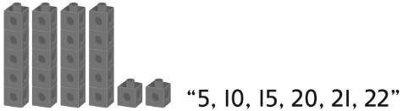  Student sees groups of cubes as one unit, fluently skip-counts by the unit, then counts on by 1s to find the total.
Observations/Documentation

