Skip-Counting Backward Behaviours/Strategies
Student mixes up the numbers in the skip-counting backward sequence.  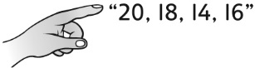 | Student counts backward by 2s to 10, then struggles to know which number comes next.  “20, 18, 16, 14, 12, 10, ?” | Student counts backward by 2s and 5s, but doesn’t know when to stop.  “50, 48, 46, 44, 42, 40, 38  Can I stop yet?” | Student counts backward by 2s, 5s, and 10s, from 50 with confidence and understanding.
Observations/Documentation

