The Fun Fair Recording Sheet
Master 38

Activity | Number of Groups | Number of Leftovers | Total
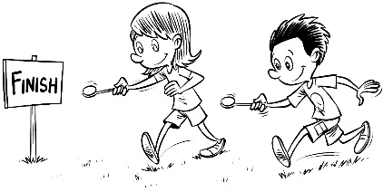
Egg and Spoon Race
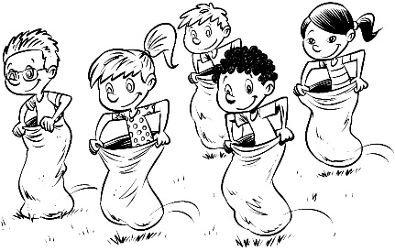
Sack Race
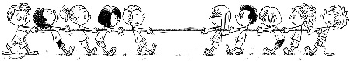
Tug of War
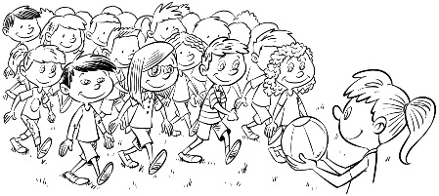
Red Light/Green Light

