Counting Sets Behaviours/Strategies
Student mixes up the number sequence when counting counters.  “1, 2, 3, 5, 7, 8, 10” | Student says number word in between “touches,” or does not say one number word for each counter counted. | 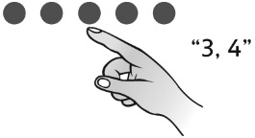  Student loses track of the count, misses counters in the count, or counts counters more than once. | Student thinks the number of objects in a set is different when the objects are rearranged or counted in a different order.  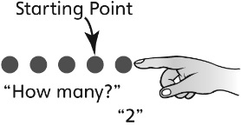
Observations/Documentation
Comparing Sets Behaviours/Strategies
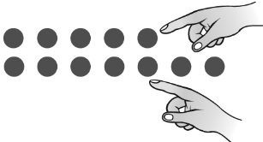  Student compares the sets using one-to-one matching. | 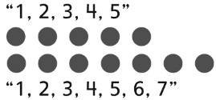  Student compares the sets using counting. | 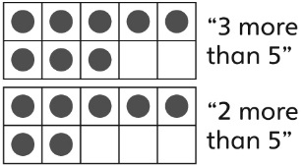  Student uses number  relationships to compare sets. | Students uses mental strategies to compare sets (e.g., visualizing ten-frames).
Observations/Documentation

