**Banana Cards**

**Master 29a**

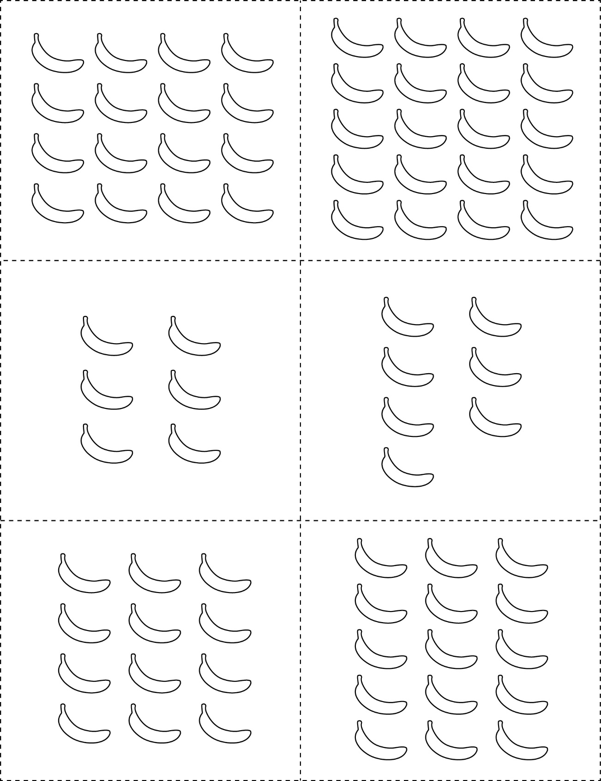



**Banana Cards**

**Master 29b**





**Banana Cards**

**Master 29c**



