Counting On and Counting Back Behaviours/Strategies
Student mixes up the number sequence when counting forward.  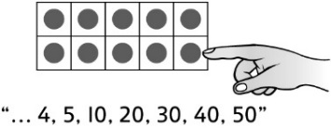 | Student adds or removes counters, then recounts from one to find how many, rather than counting on or counting back. | Student mixes up the number sequence when counting back.  “19, 18, 16, 14, 15”
Observations/Documentation
Student has difficulty keeping track of the number counted on or back (how many have been added or removed, and the numbers in the counting sequence).  “5, 6, 7, 8…  Did I count enough?” | 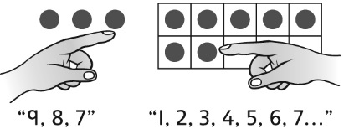  Student counts on or back, then counts from 1 to check. | Student counts on or back with ease.  “50, 49, 48, 47, 46”
Observations/Documentation

