***Hopping Back* Game Boards**

**Master 9a**

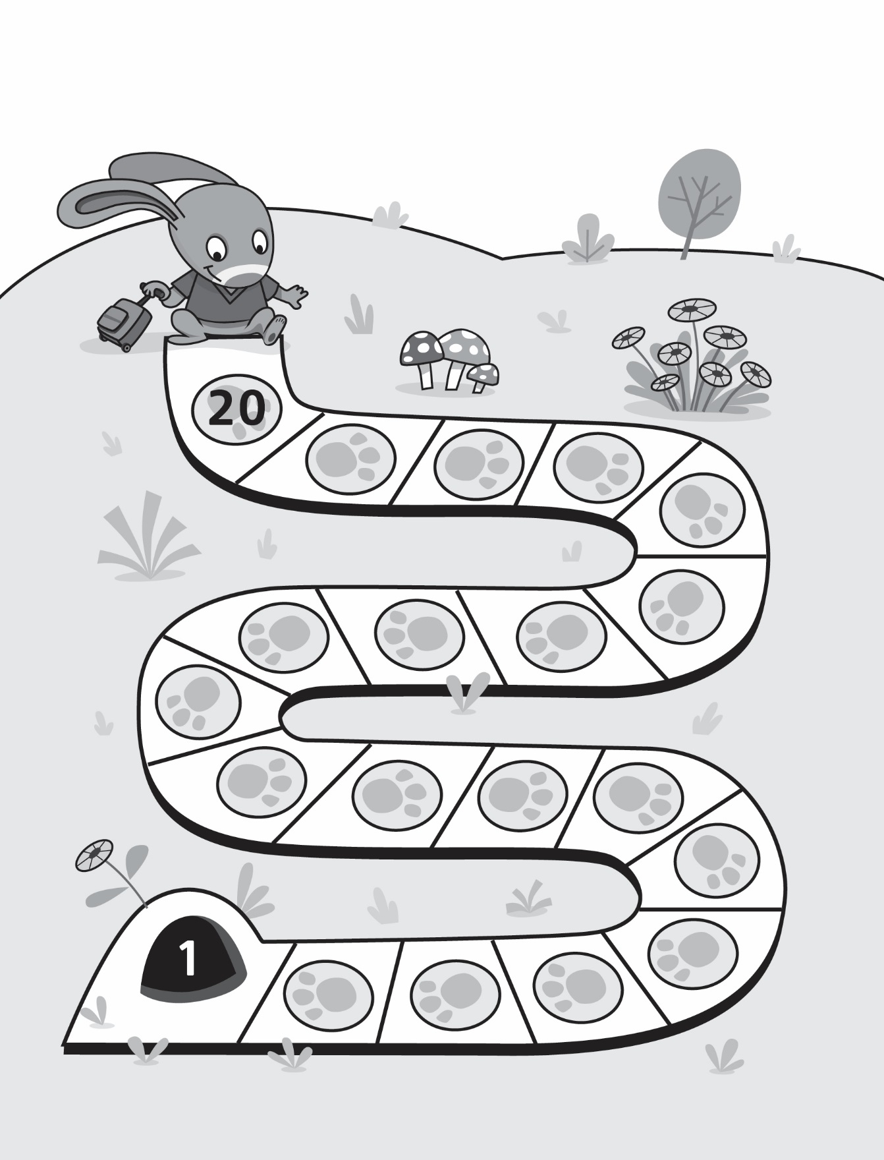

***Hopping Back* Game Boards**

**Master 9b**

**(for Accommodation)**

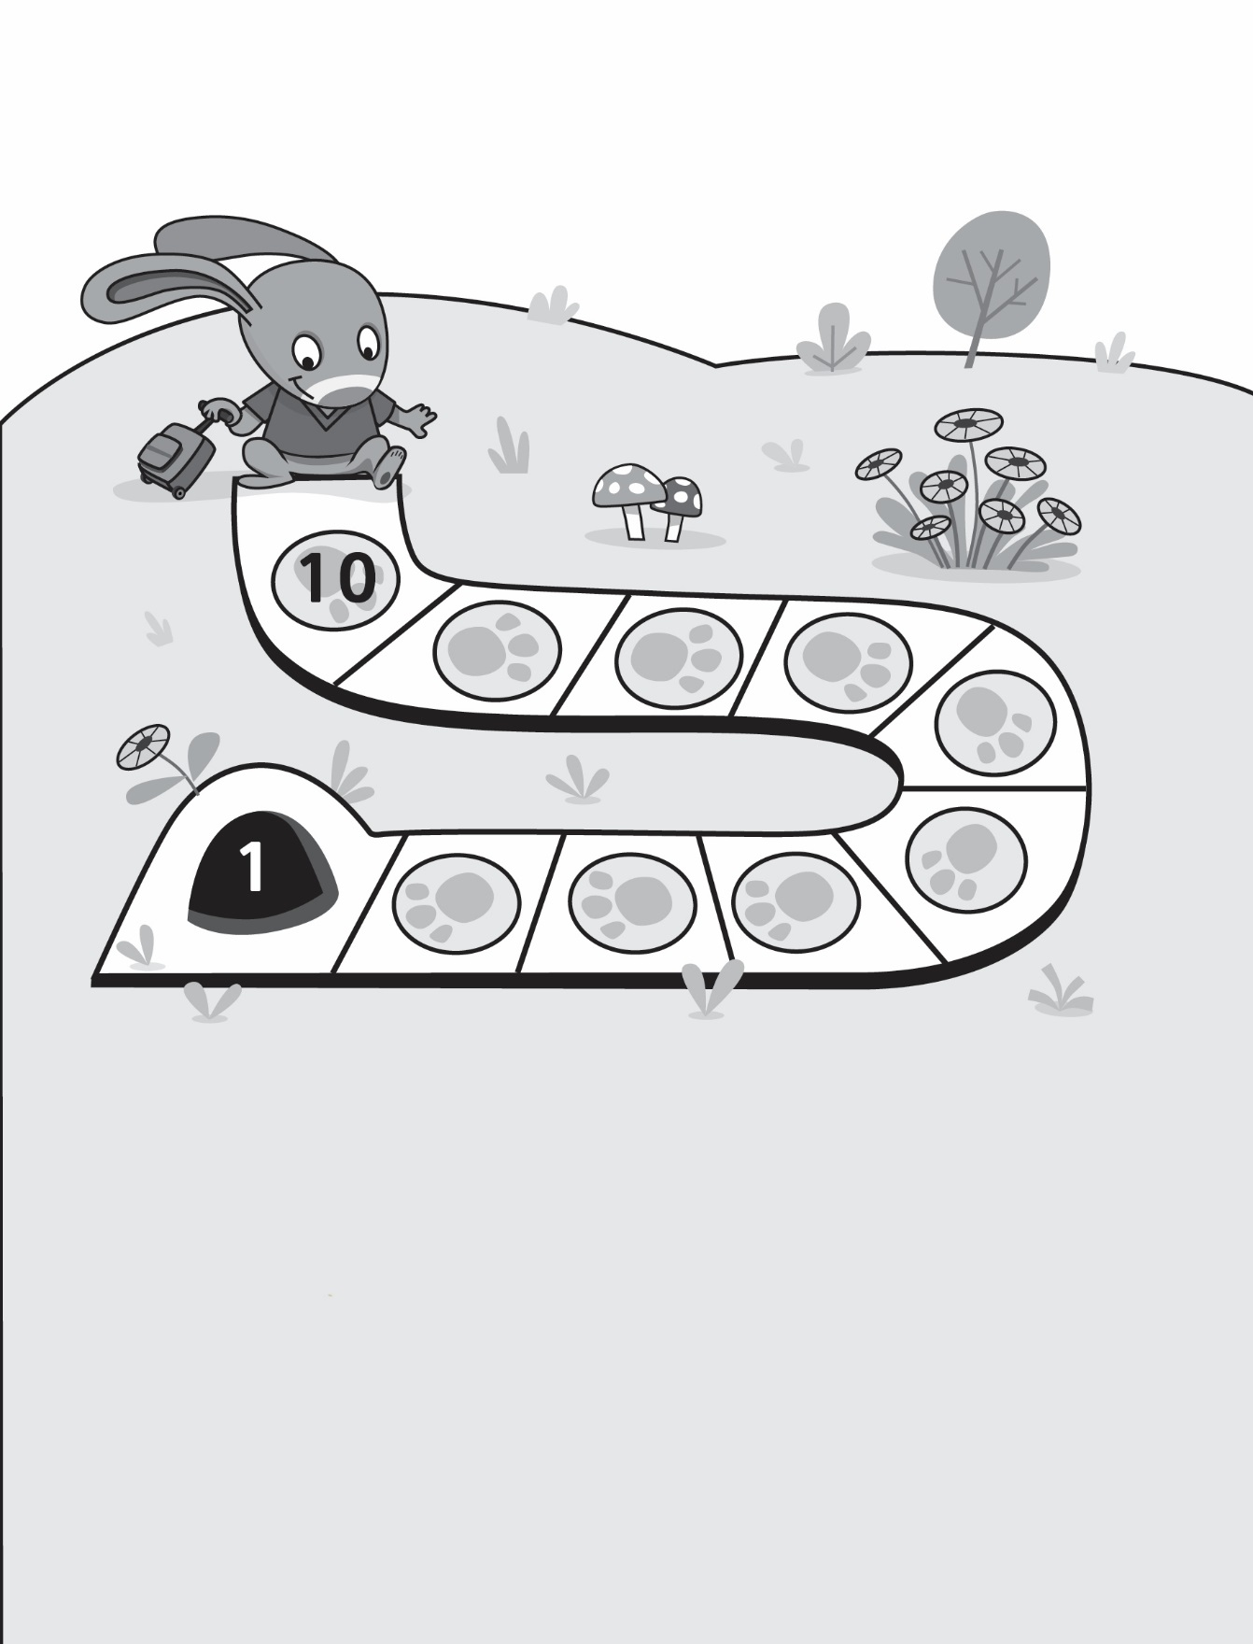

***Hopping Back* Game Boards**

**Master 9c**

***Hopping Back* Game Boards**

**Master 9d**

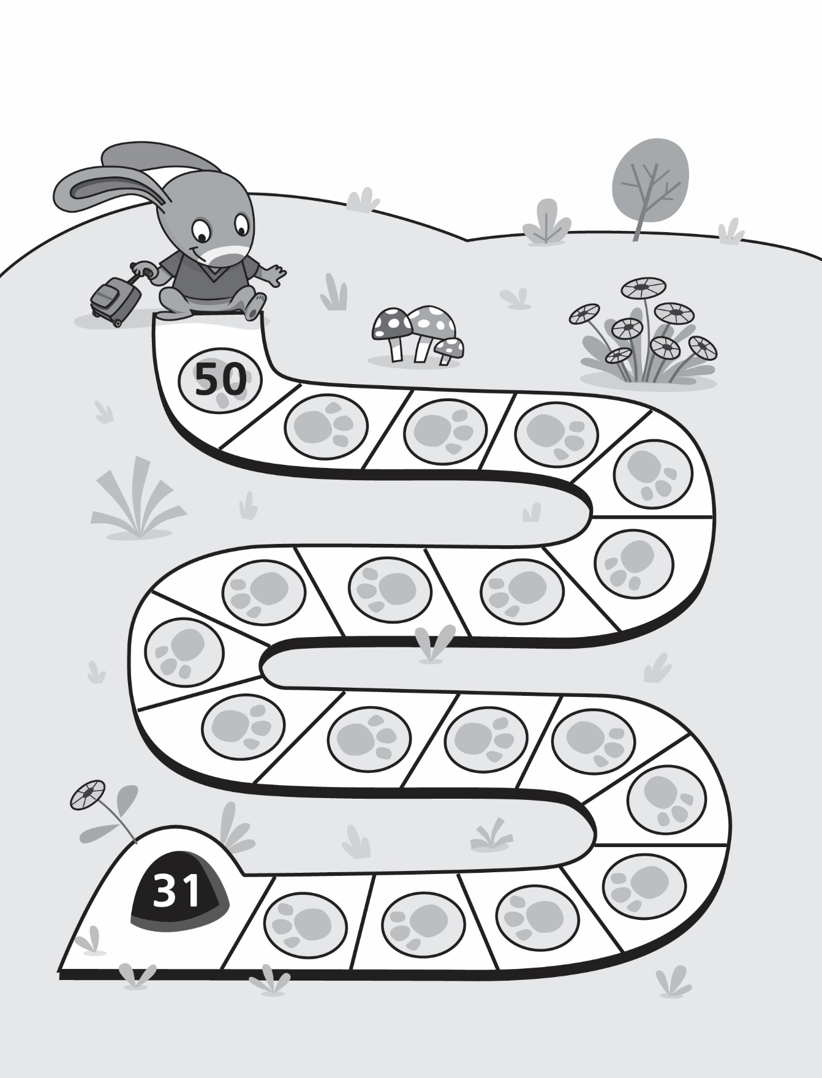

***Hopping Back* Game Boards**

**Master 9e**

**(for Extension)**

