Calendar Game Board A
Master 21a

June
Sunday | Monday | Tuesday | Wednesday | Thursday | Friday | Saturday
 |  | 1 | 2 | 3 | 4 | 5
6 | 7 | 8 | 9  Zoo  Field Trip | 10 | 11 | 12
13 | 14 | 15 | 16 | 17 | 18  Class Pizza Party | 19
20  Longest Day of the Year | 21  National Indigenous Peoples Day | 22 | 23 | 24 | 25 | 26
27 | 28 | 29  School’s Out | 30

Calendar Game Board A
Master 21b

November
Sunday | Monday | Tuesday | Wednesday | Thursday | Friday | Saturday
 | 1 | 2 | 3 | 4  Diwali (Festival of Lights) | 5  Yard Waste  Collection  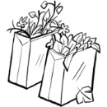 | 6
7  Daylight Savings Time Ends | 8 | 9 | 10 | 11  Remembrance  Day | 12 | 13
14 | 15 | 16 | 17 | 18 | 19  Yard Waste  Collection | 20  Fun Fair
21 | 22 | 23 | 24 | 25 | 26 | 27
28 | 29  First Day of Hanukkah  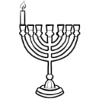 | 30

Calendar Game Board B
Master 21c

February
Sunday | Monday | Tuesday | Wednesday | Thursday | Friday | Saturday
 |  | 1  Lunar New Year | 2  Groundhog  Day  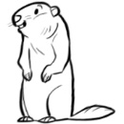 | 3 | 4 | 5
6 | 7 | 8 | 9 | 10 | 11 | 12
13 | 14  Valentine’s  Day | 15 | 16 | 17 | 18 | 19
20 | 21  Family Day | 22 | 23 | 24  Barney the Hamster’s Birthday  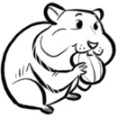 | 25 | 26
27 | 28

Calendar Game Board B
Master 21d

May
Sunday | Monday | Tuesday | Wednesday | Thursday | Friday | Saturday
1 | 2 | 3  Eid al-Fitr | 4 | 5  Cinco de Mayo | 6 | 7
8  Mother’s Day | 9 | 10 | 11 | 12 | 13  Tulip Festival Begins | 14
15 | 16 | 17 | 18 | 19 | 20 | 21
22 | 23  Victoria Day  Tulip Festival Ends | 24 | 25 | 26 | 27 | 28
29 | 30 | 31

