Comparing Objects by Mass Behaviours/Strategies
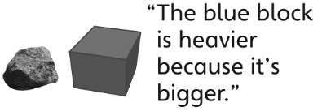  Student thinks a larger object has a greater mass. | Student uses hands to compare the mass of objects and always says the object in his or her dominant hand is lighter/heavier. | Student thinks the heavier object is in the higher pan of the pan balance.  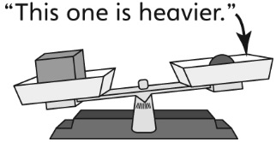
Observations/Documentation
Student compares the mass of each object to all others. | Student correctly orders the objects but has difficulty using measurement language to compare the masses. | Student correctly orders the objects and uses measurement language to compare the masses.
Observations/Documentation

