Reading and Writing Codes with Numbers and Arrows Behaviours/Strategies
- Student describes the movement from one location to another on a grid and uses arrows on the grid to show a path, but struggles to write code.  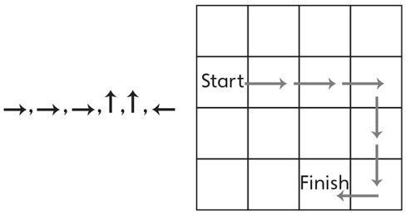 | - Student describes the movement from one  location to another on a grid, but writes code by counting squares instead of steps, resulting in extra arrows.  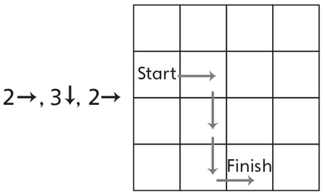 | - Student describes the movement from one  location to another on a grid, but writes  incorrect code.  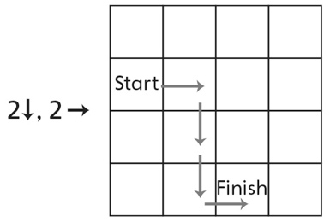
Observations/Documentation
- Student describes the movement from one  location to another on a grid and writes code,  but struggles to read code. | - Student describes the movement from one  location to another on a grid and reads and  writes codes, but cannot spot the incorrect code.  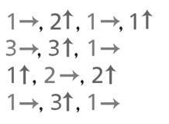 | - Student describes the movement from one  location to another on a grid, reads and writes codes, and spots and corrects incorrect codes.
Observations/Documentation

