**My Cube Path**

**Master 39a**

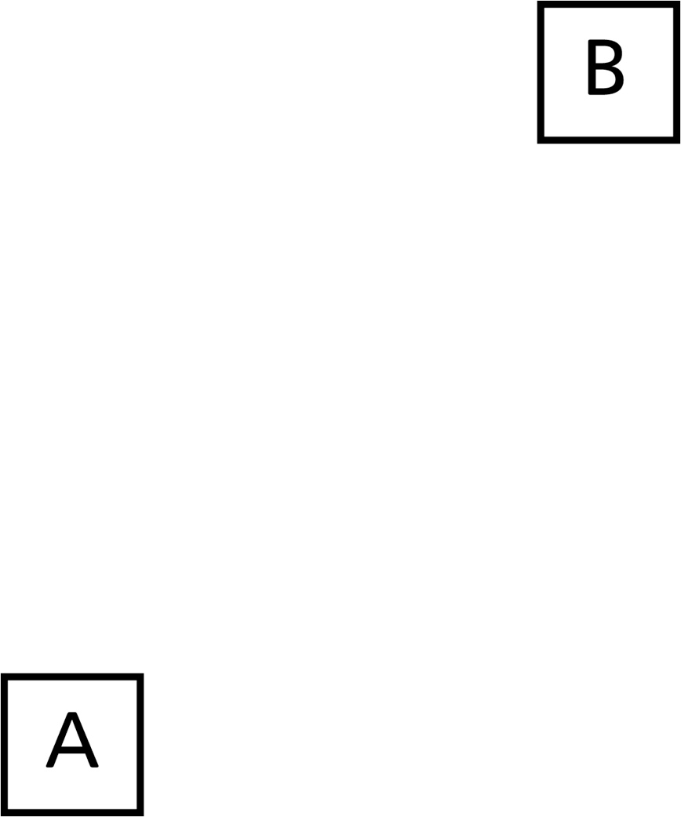

**My Cube Path   
(For Accommodations)**

**Master 39b**

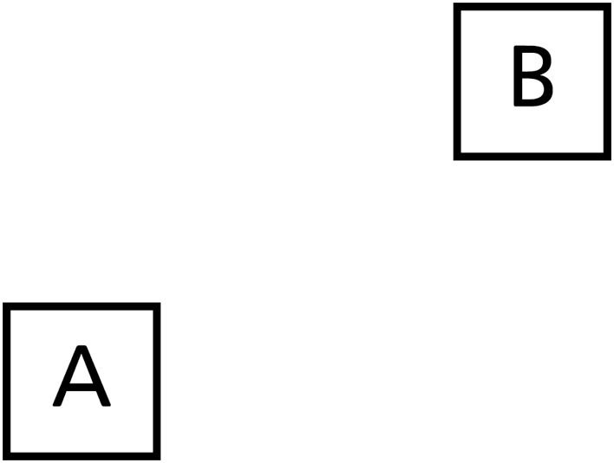

**My Cube Path   
(For Extension)**

**Master 39c**

