**Symmetrical Images**

**Master 25a**

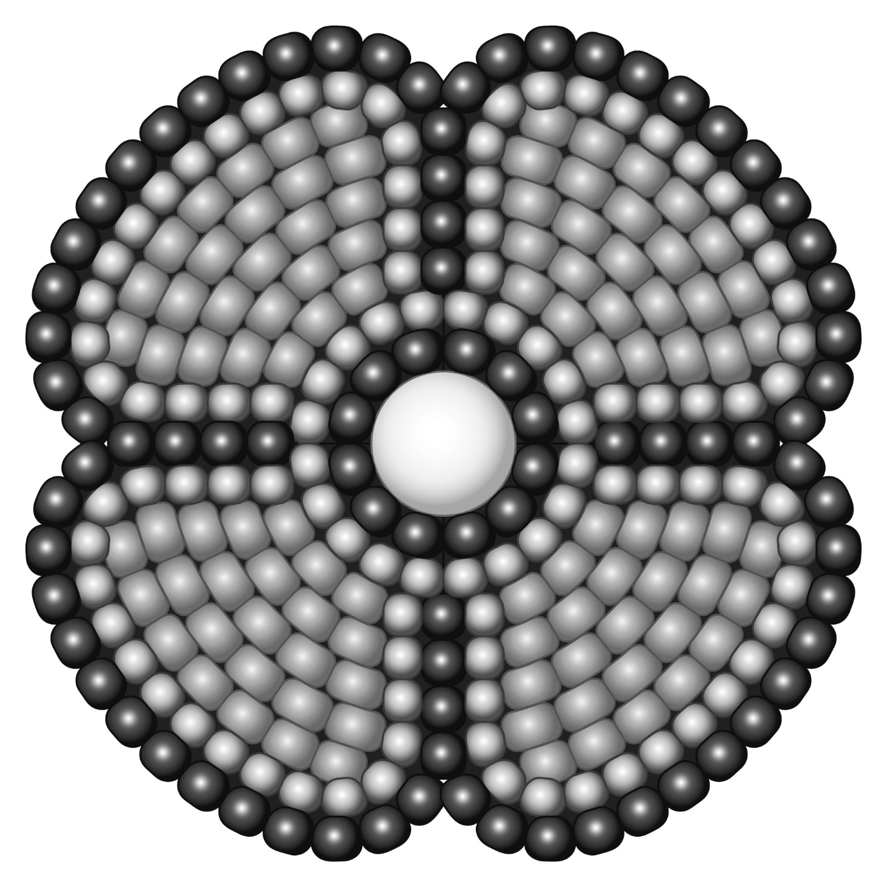

**Symmetrical Images**

**Master 25**



**Symmetrical Images**

**Master 25c**



**Symmetrical Images**

**Master 25d**



**Symmetrical Images**

**Master 25e**



**Symmetrical Images**

**Master 25f**



**Symmetrical Images**

**Master 25g**



**Symmetrical Images**

**Master 25h**

