**Exploring Lines of Symmetry**

**Master 24a**



**Exploring Lines of Symmetry**

**Master 24b**



**Exploring Lines of Symmetry**

**Master 24c**

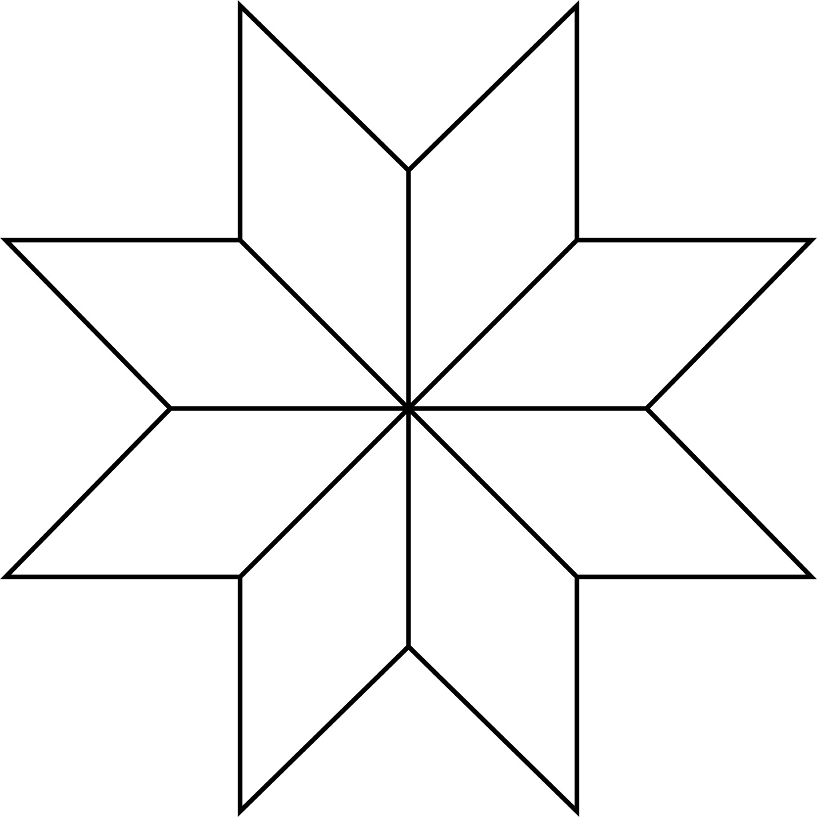

**Exploring Lines of Symmetry**

**Master 24d**

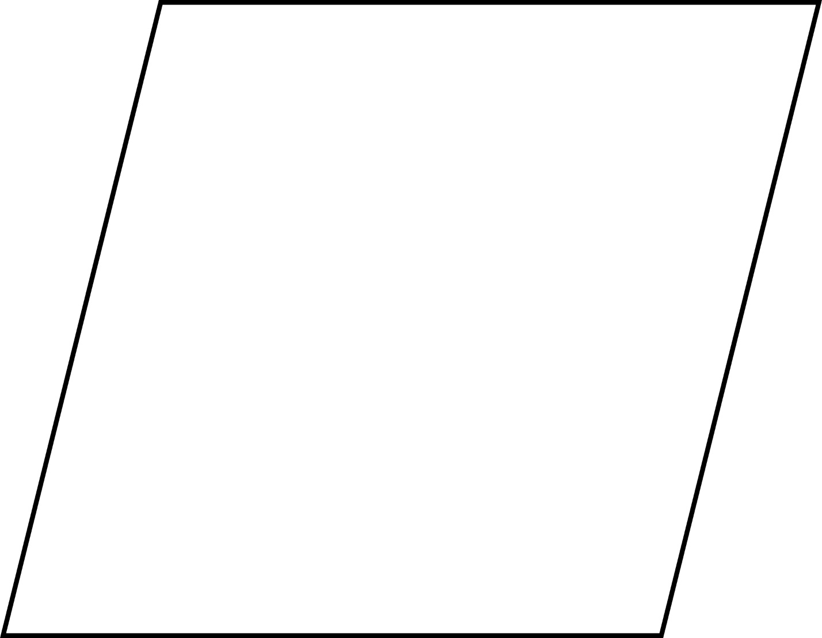

**Exploring Lines of Symmetry**

**Master 24e**

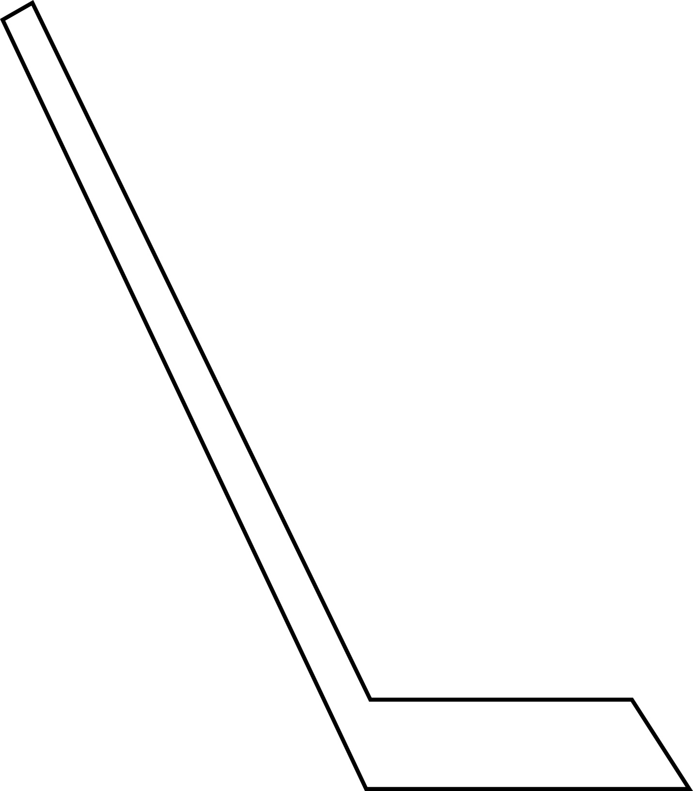

**Exploring Lines of Symmetry**

**Master 24f**

