Making Concrete Graphs Behaviours/Strategies
Student has difficulty sorting the cubes. | 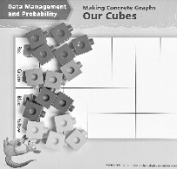  Student sorts the cubes into piles on the graph. | 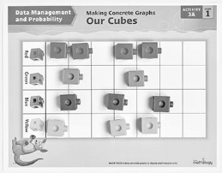  Student sorts cubes in lines, but cubes are not equally spaced and aligned. | 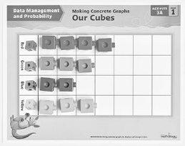  Student sorts cubes in lines on the graph, placing one cube in each space.
Observations/Documentation
Reading Concrete Graphs Behaviours/Strategies
Student has difficulty counting the number of cubes in a column.  “I think I counted that cube already.” | Student sorts and counts the cubes but has difficulty reading simple data from the graph (e.g., “Which column has the most cubes?”). | Student reads data from the graph but has difficulty comparing the data. | Student answers “how many” questions about the graph and compares data using terms such as “more,” “fewer,” “most,” and “least.”
Observations/Documentation

