Sorting Objects Using One Attribute Behaviours/Strategies
Student identifies attributes of objects but struggles to sort them.  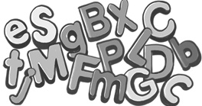  “The letters are of different colours and sizes. Some are big letters and some are small.” | Student sorts a collection of objects in one way.  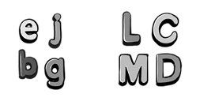  “These letters are small and these letters are big. I don’t know how to sort them another way.” | Student sorts a collection of objects in different ways but can’t identify sorting rule for pre-sorted set.  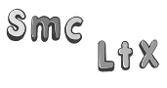  “I sorted into 2 groups:  letters with curves and  letters without curves.”  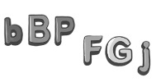  “I’m not sure what  the sorting rule is.  The colours are different  and the sizes are different.” | Student flexibly sorts a collection of objects in different ways and identifies sorting rule for pre-sorted set.  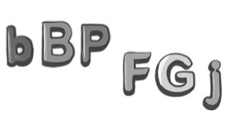  “The sorting rule is: Objects with holes and objects without holes.”
Observations/Documentation

