Patterns in Cycles Behaviours/Strategies
Student recognizes the pattern is a cycle but struggles to identify the pattern core.  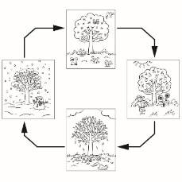  “I can’t find the core.  I don’t see parts that repeat.” | Student recognizes the pattern is a cycle but struggles to identify the missing element.  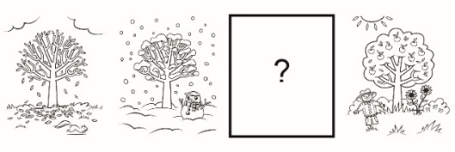  “I know they’re the seasons.” | Student has difficulty describing change and constancy in cycles.
Observations/Documentation
Student creates different representations of the same cycle but does not recognize the cycles are the same.  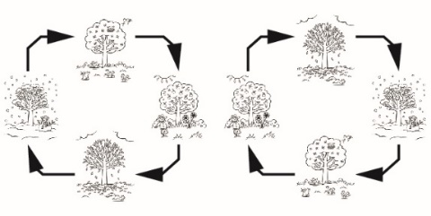 | 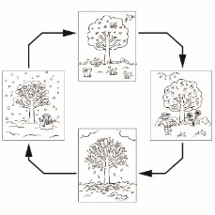  Student has difficulty extending the pattern in the cycle.  “It’s done. I don’t know what comes next.” | Student recognizes patterns in cycles and identifies the pattern core and missing elements. Student describes change and constancy in the cycles, creates different representations of the same cycles, and extends the patterns.
Observations/Documentation

