Cycles Go Round and Round
Master 32a

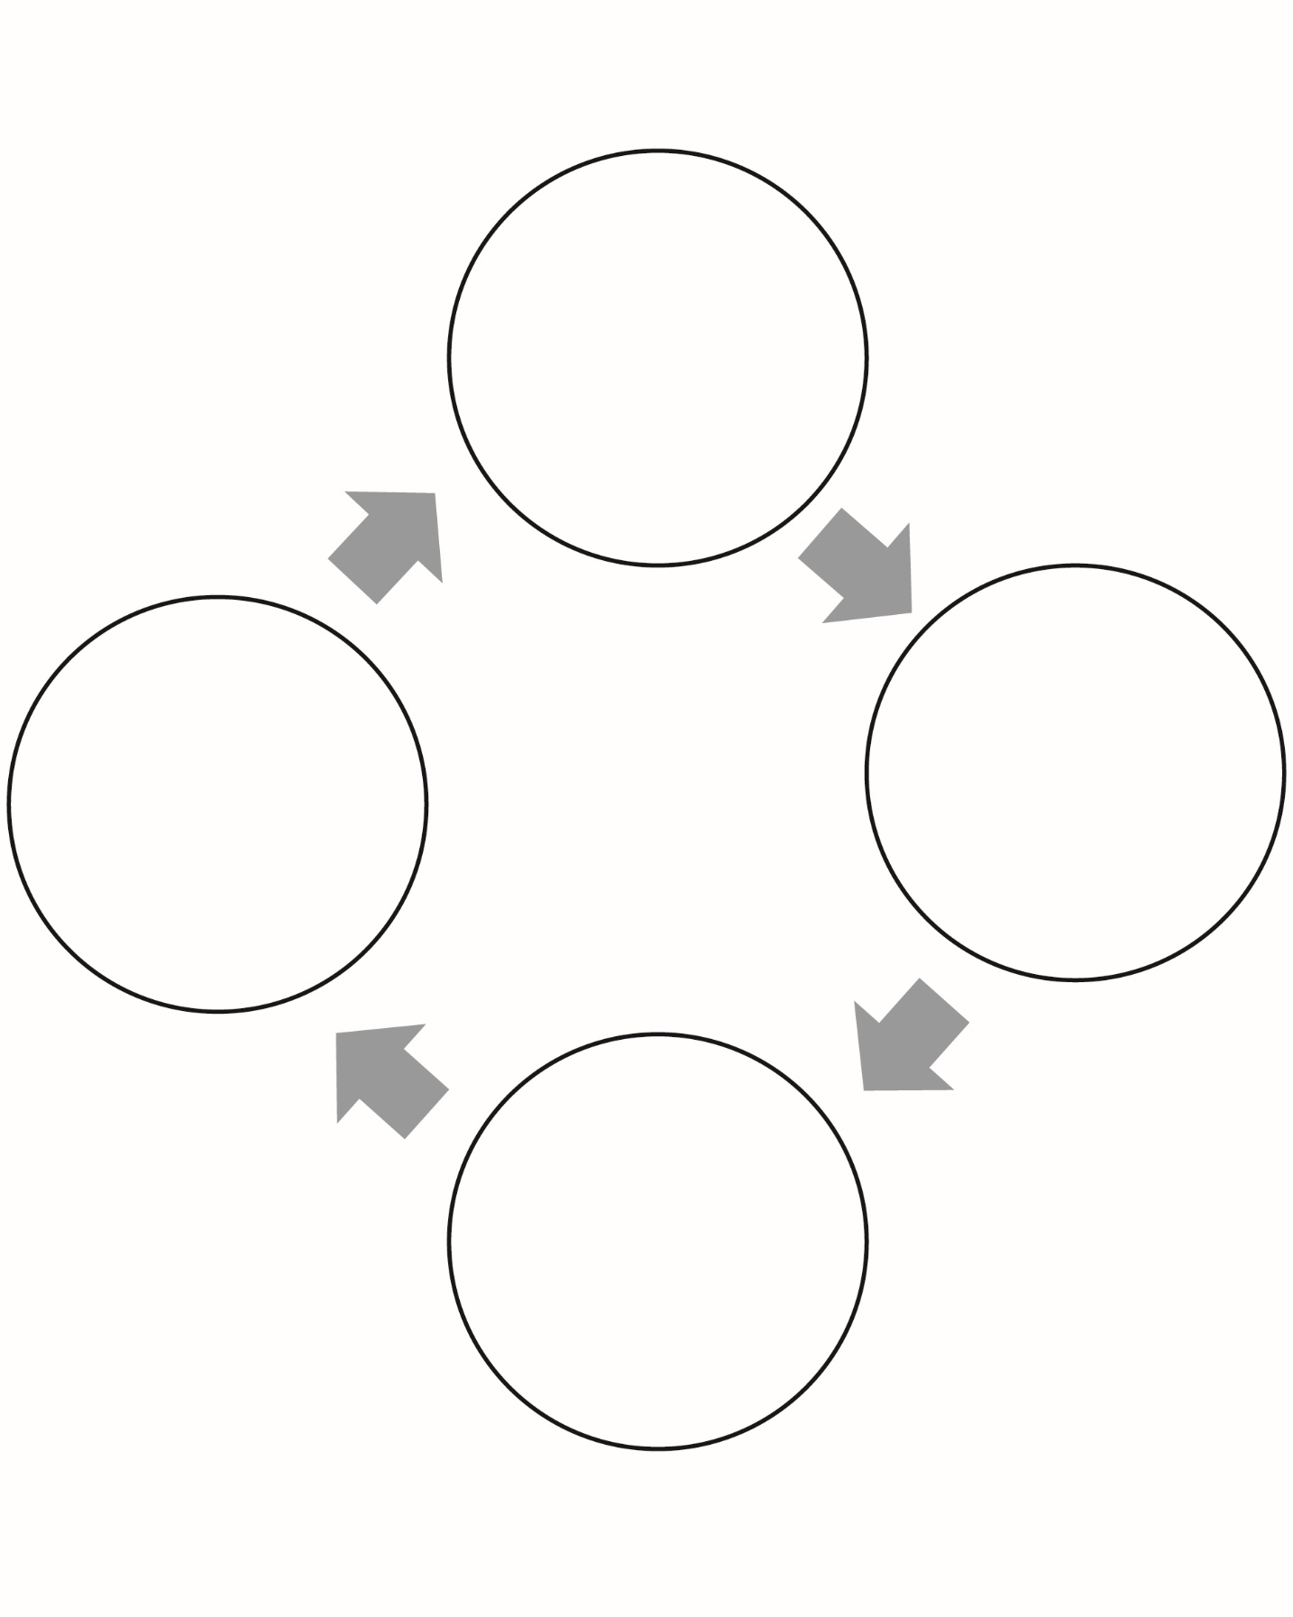
Cycles Go Round and Round
(Accommodations)
Master 32b

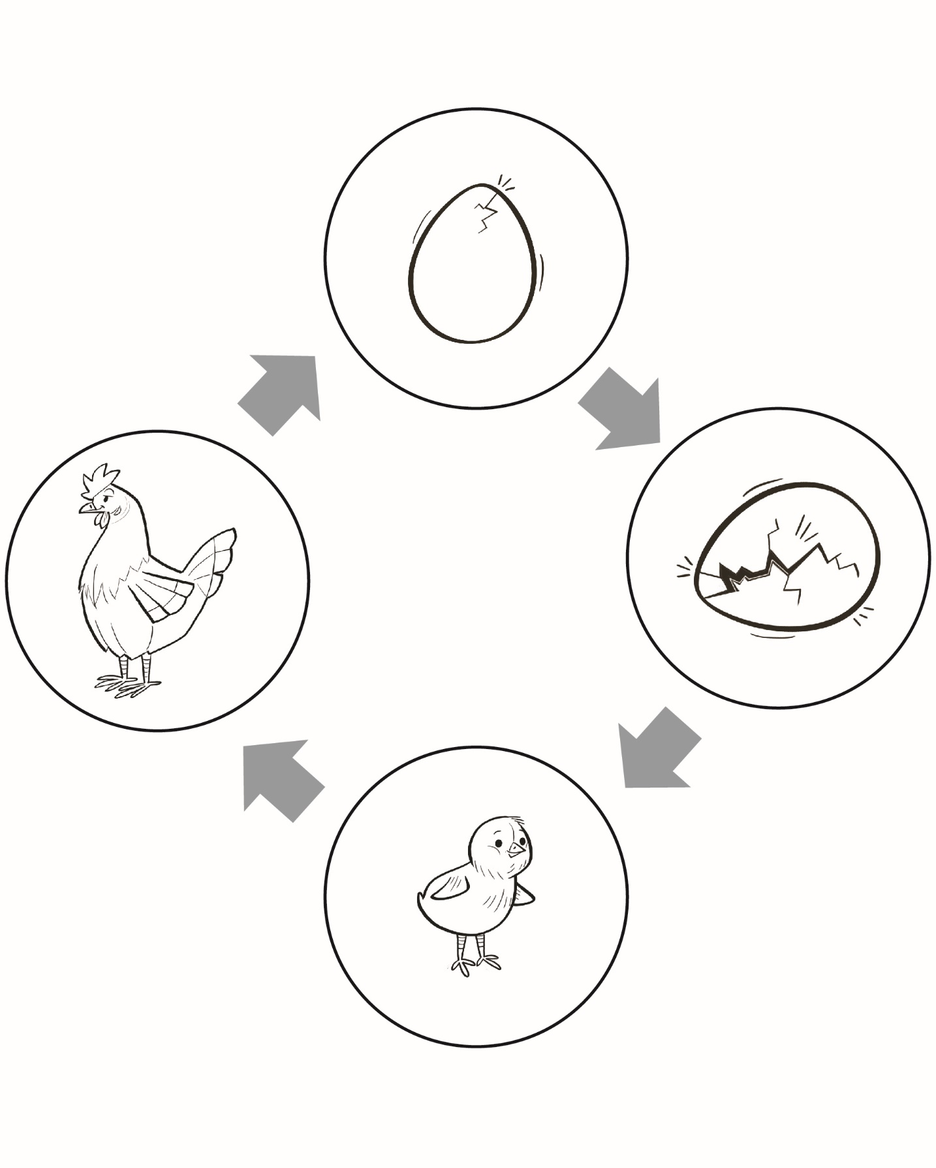
Cycles Go Round and Round (Extension)
Master 32c

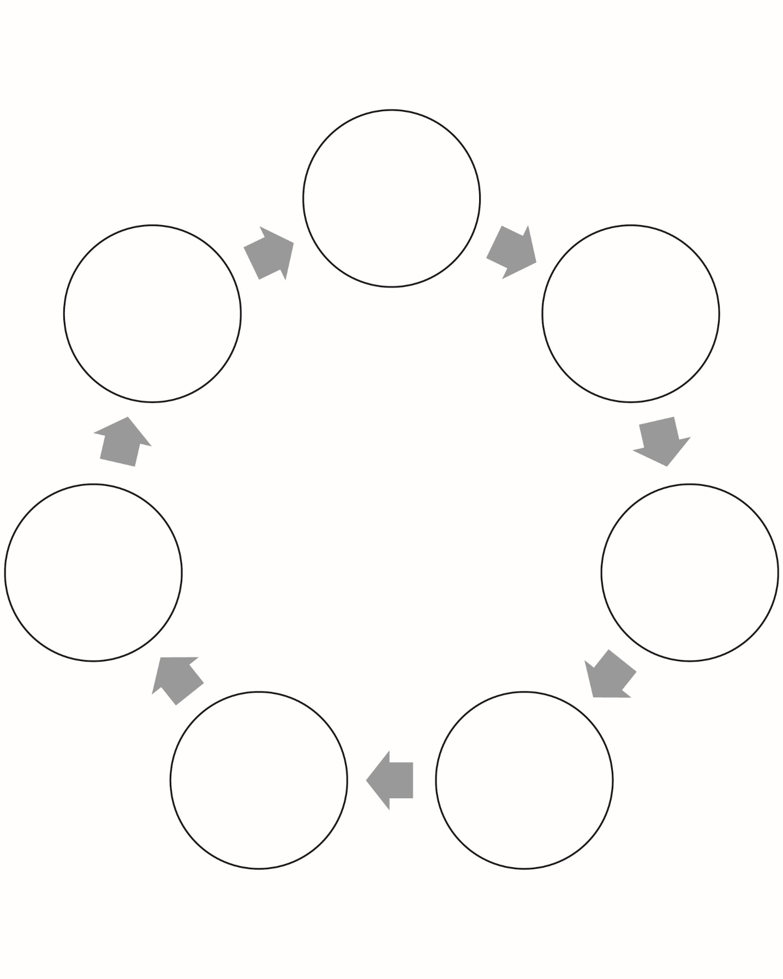
Cycles Go Round and Round (Extension)
Master 32d

