Creating and Extending Patterns in Cycles Behaviours/Strategies
Student identifies the elements of a cycle but struggles to place them in any sequence.  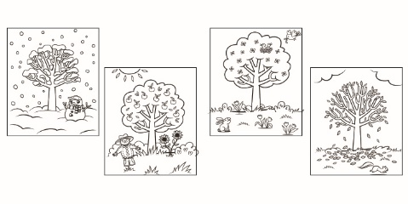  “This picture is winter, this one summer. This one means spring and this one means fall.” | 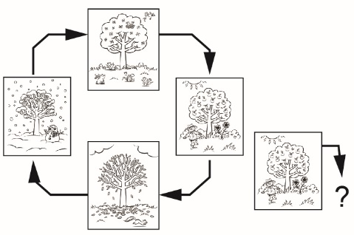  Student creates a representation of the pattern cycle once, but struggles to demonstrate how it continues from any given point.  “When I start with this one, I don’t know what comes next.” | Student creates a representation of the pattern cycle once, but struggles to extend it, or demonstrate how it continues repeatedly.  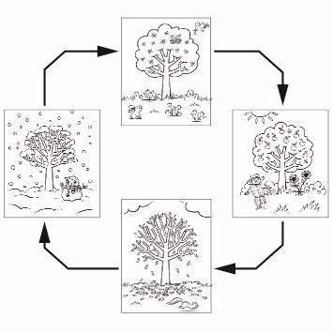  “It’s done. I don’t know  what comes next.” | Student creates different representations of patterns in cycles and extends them with ease.
Observations/Documentation

