Identifying and Describing Patterns in Cycles Behaviours/Strategies
Student recognizes the elements of the pattern as a cycle but struggles to identify the missing element.  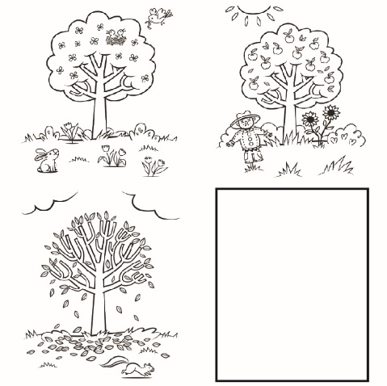  “I know they’re the seasons.” | Student struggles to identify the pattern core in a cycle.  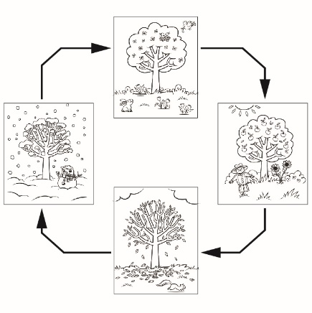  “I can’t find the core.  I don’t see parts that repeat.” | Student struggles to understand change and constancy in repeating patterns and cycles.  “Dogs don’t grow like people.” | Student identifies the pattern core and missing parts of patterns in cycles and describes change and constancy in them with ease.
Observations/Documentation

