Extending and Describing Behaviours/Strategies
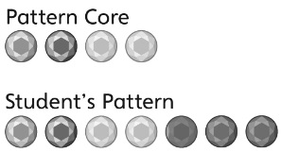  Student randomly draws circles to extend the pattern. | Student repeats only the last jewel in the core.  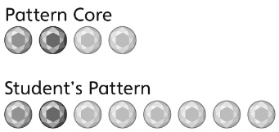 | 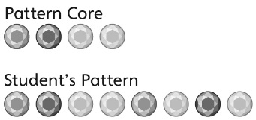  Student draws the jewels with the correct colours but places them in the wrong order.
Observations/Documentation
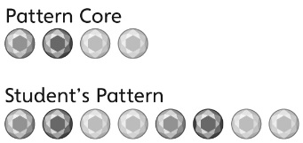  Student accurately extends the pattern but has difficulty describing the pattern. | Student accurately extends and describes the pattern but has difficulty representing it with letters. | Student accurately extends and describes the pattern and represents it with letters.
Observations/Documentation

