**Pattern Cards**

**Master 3a**

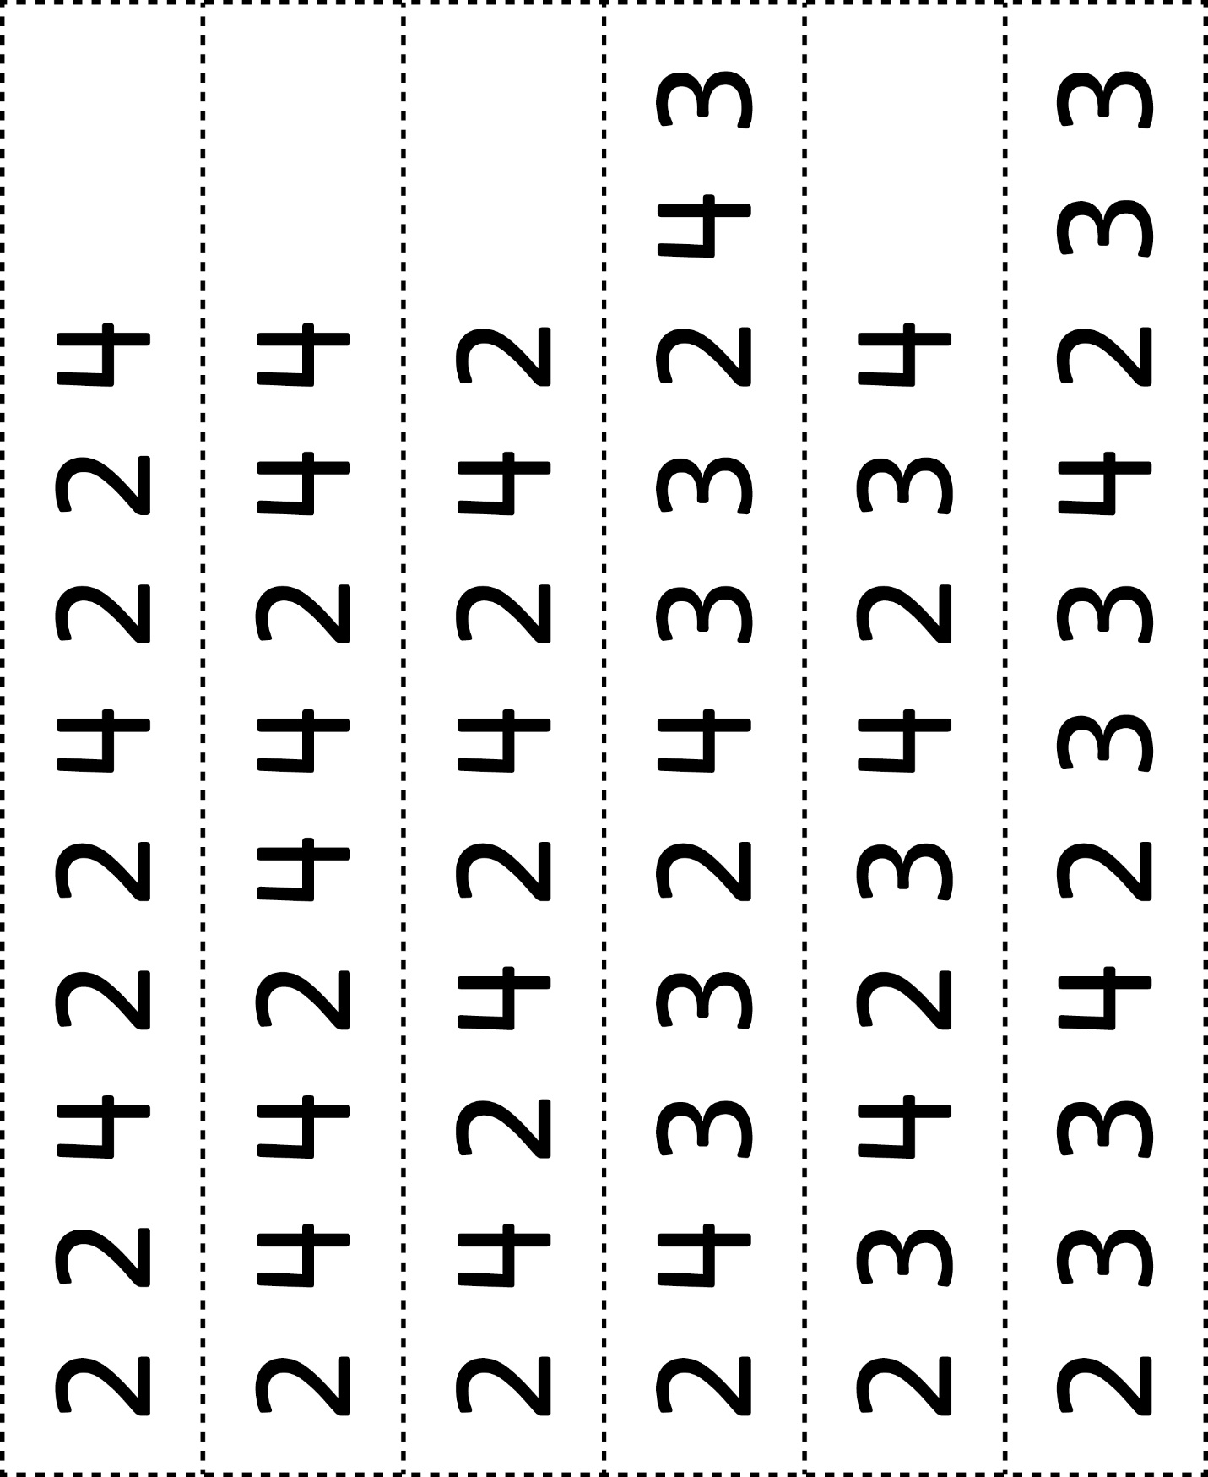



**Pattern Cards**

**Master 3b**

