Neighbourhood Goods and Services
Master 113a

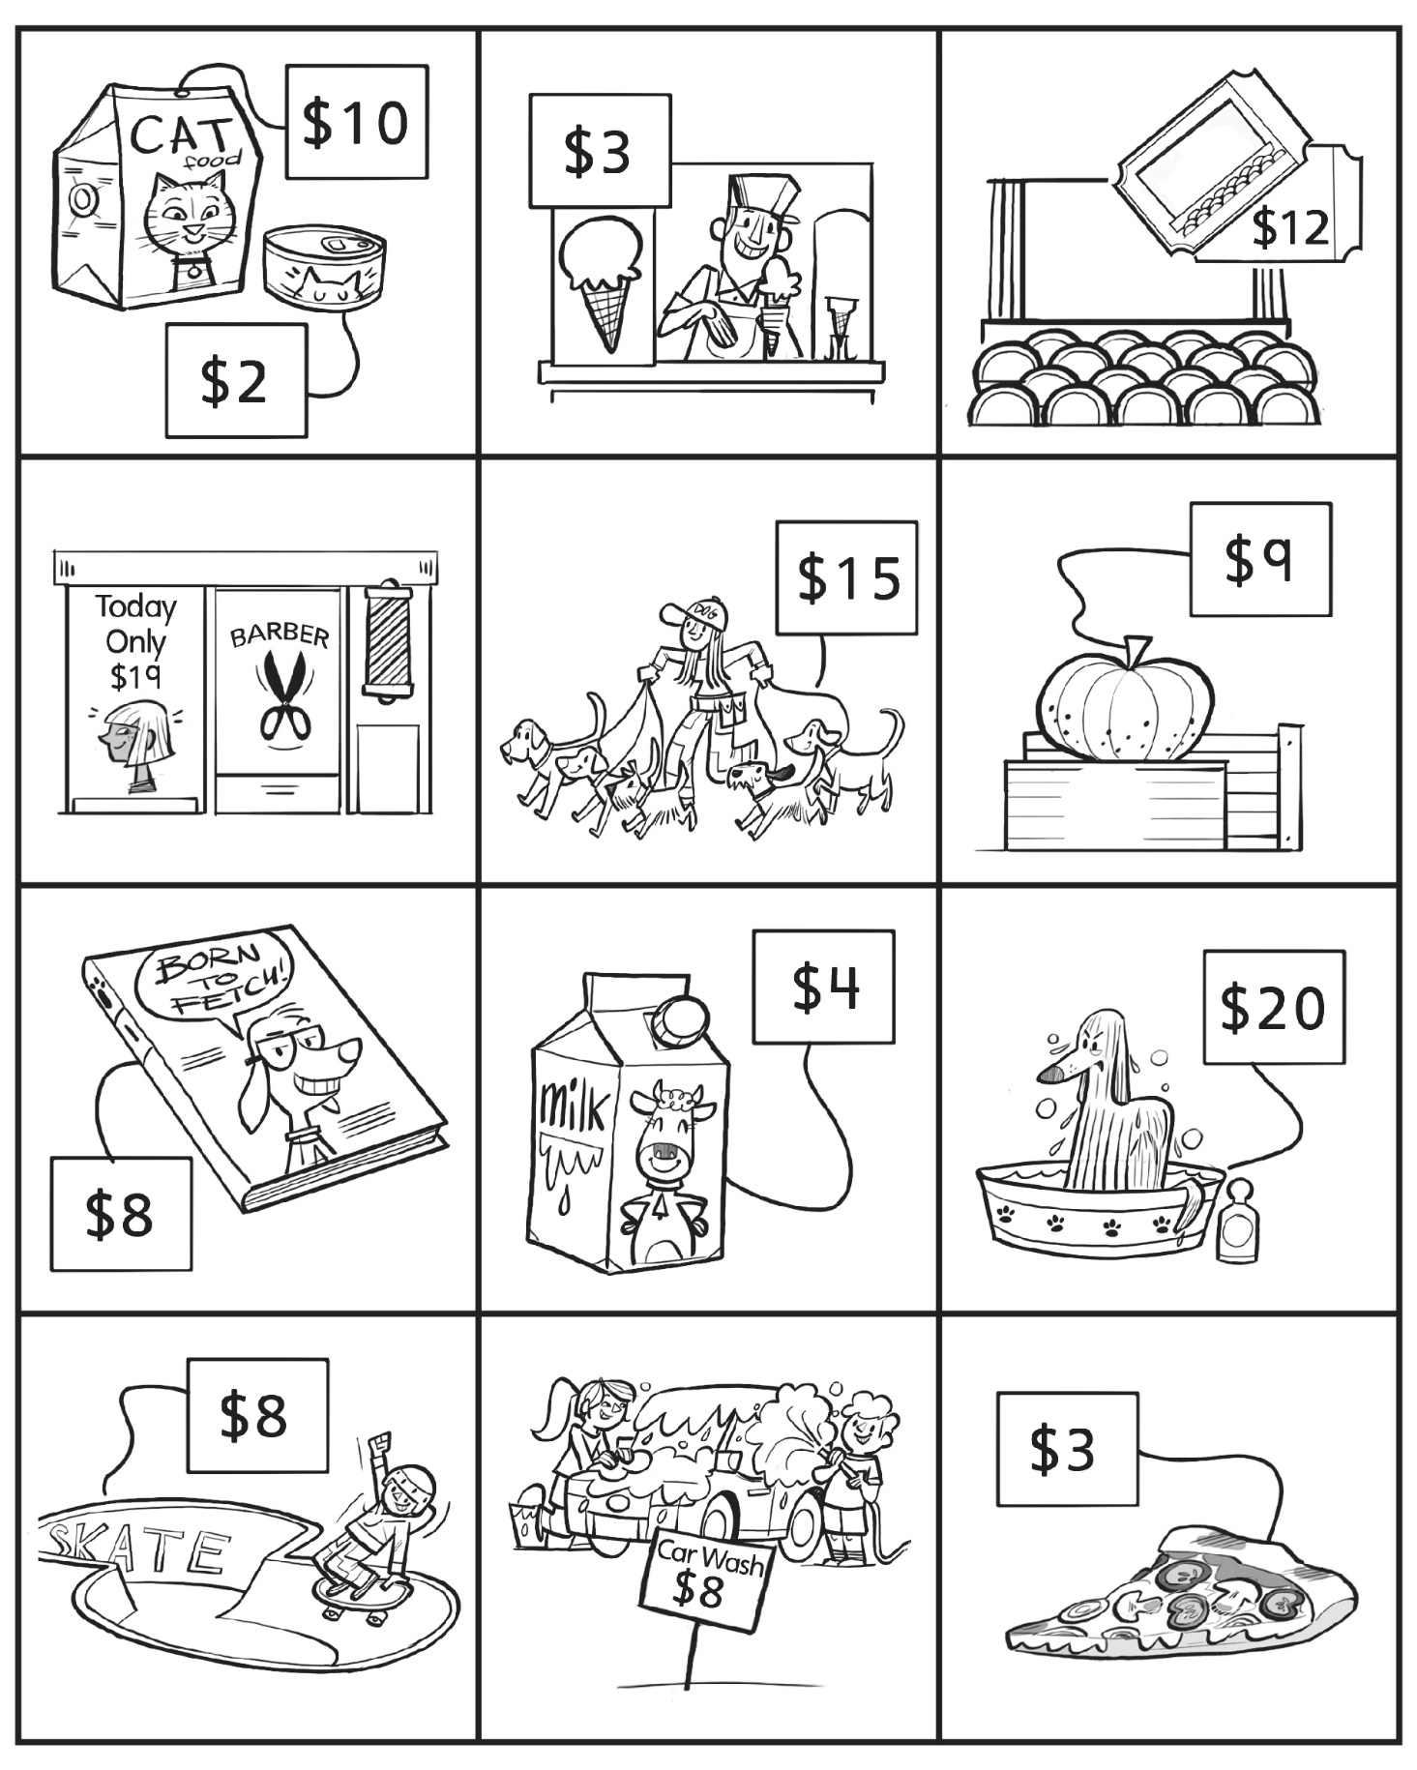
Neighbourhood Goods and Services
Master 113b

Draw a good and a service in the box.

