Exchanging Money for Goods and Services Behaviours/Strategies
Student has difficulty identifying the difference between goods and services. | Student can identify goods and services but is unable to explain why they are goods and services. | Student has difficulty sorting coins and bills, or recognizing the attributes that show their value.  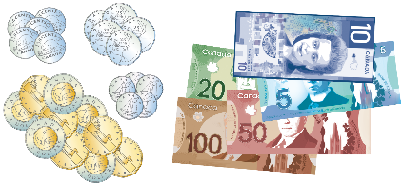 | Student identifies goods and services with ease, sorts bills and coins accurately, and uses bills and coins to pay for goods and services.
Observations/Documentation

