**Money Cutouts**

**Master 110a**

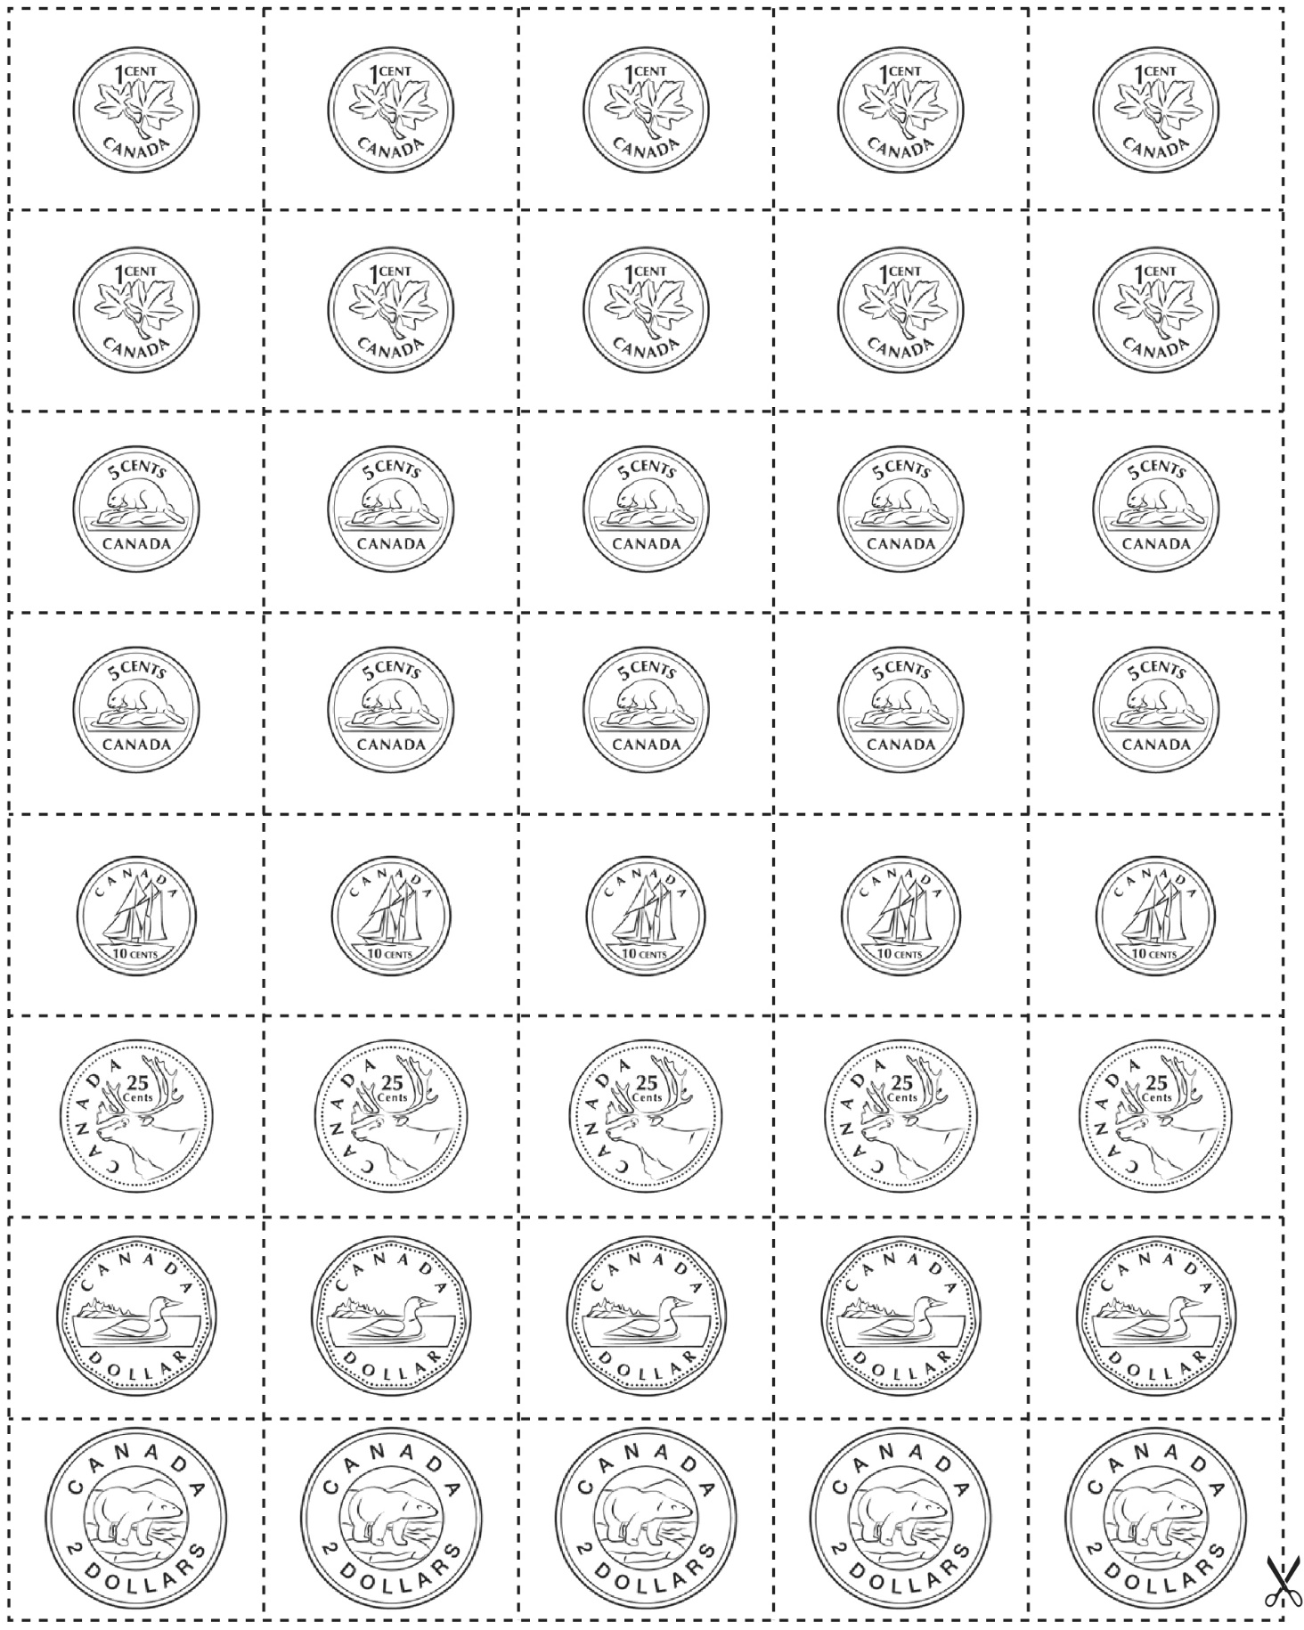

**Money Cutouts**

**Master 110b**

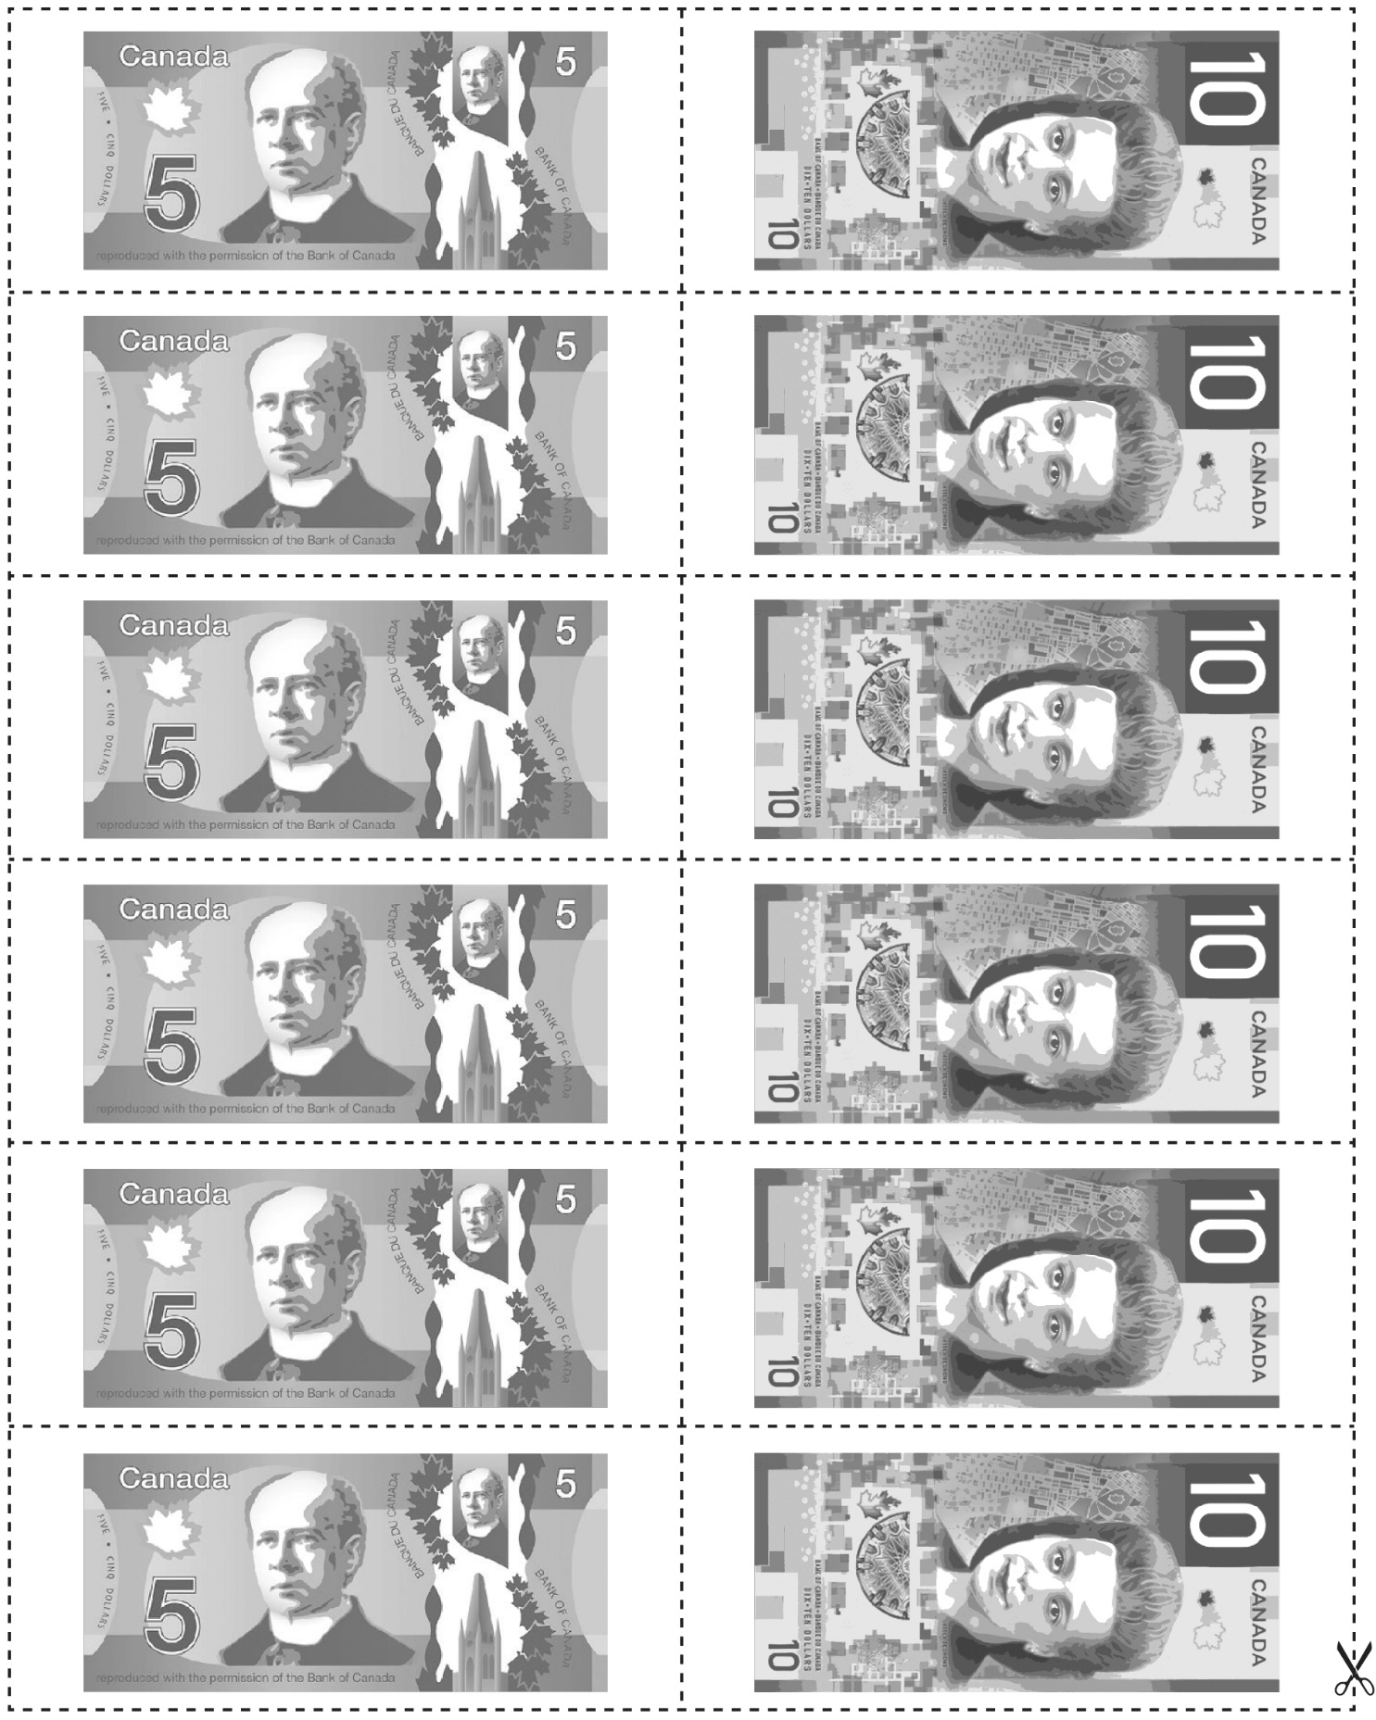

**Money Cutouts**

**Master 110c**

