Counting and Representing Money Amounts Behaviours/Strategies
Student needs to count to trust the value of a coin. | 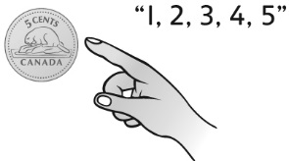  Student touches a nickel and says “1, 2, 3, 4, 5.” | 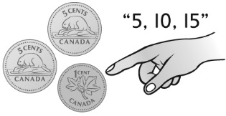  Student continues to skip-count by 5s when the next coin is a cent. | 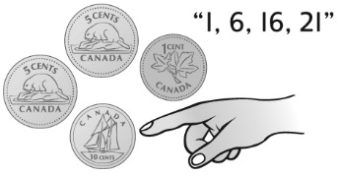  Student randomly counts a collection of coins.
Observations/Documentation
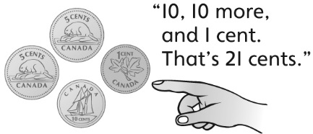  Student sorts then counts a collection of coins. | Student randomly selects coins to represent a money amount in a different way, paying no attention to values. | Student clears all the coins away and starts fresh to represent a money amount in a different way. | 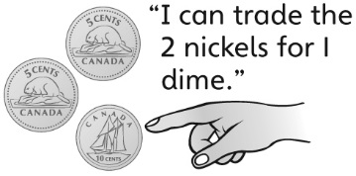  Student systematically trades coins to represent a money amount in different ways.
Observations/Documentation

