**Coin Cards**

**Master 97a**

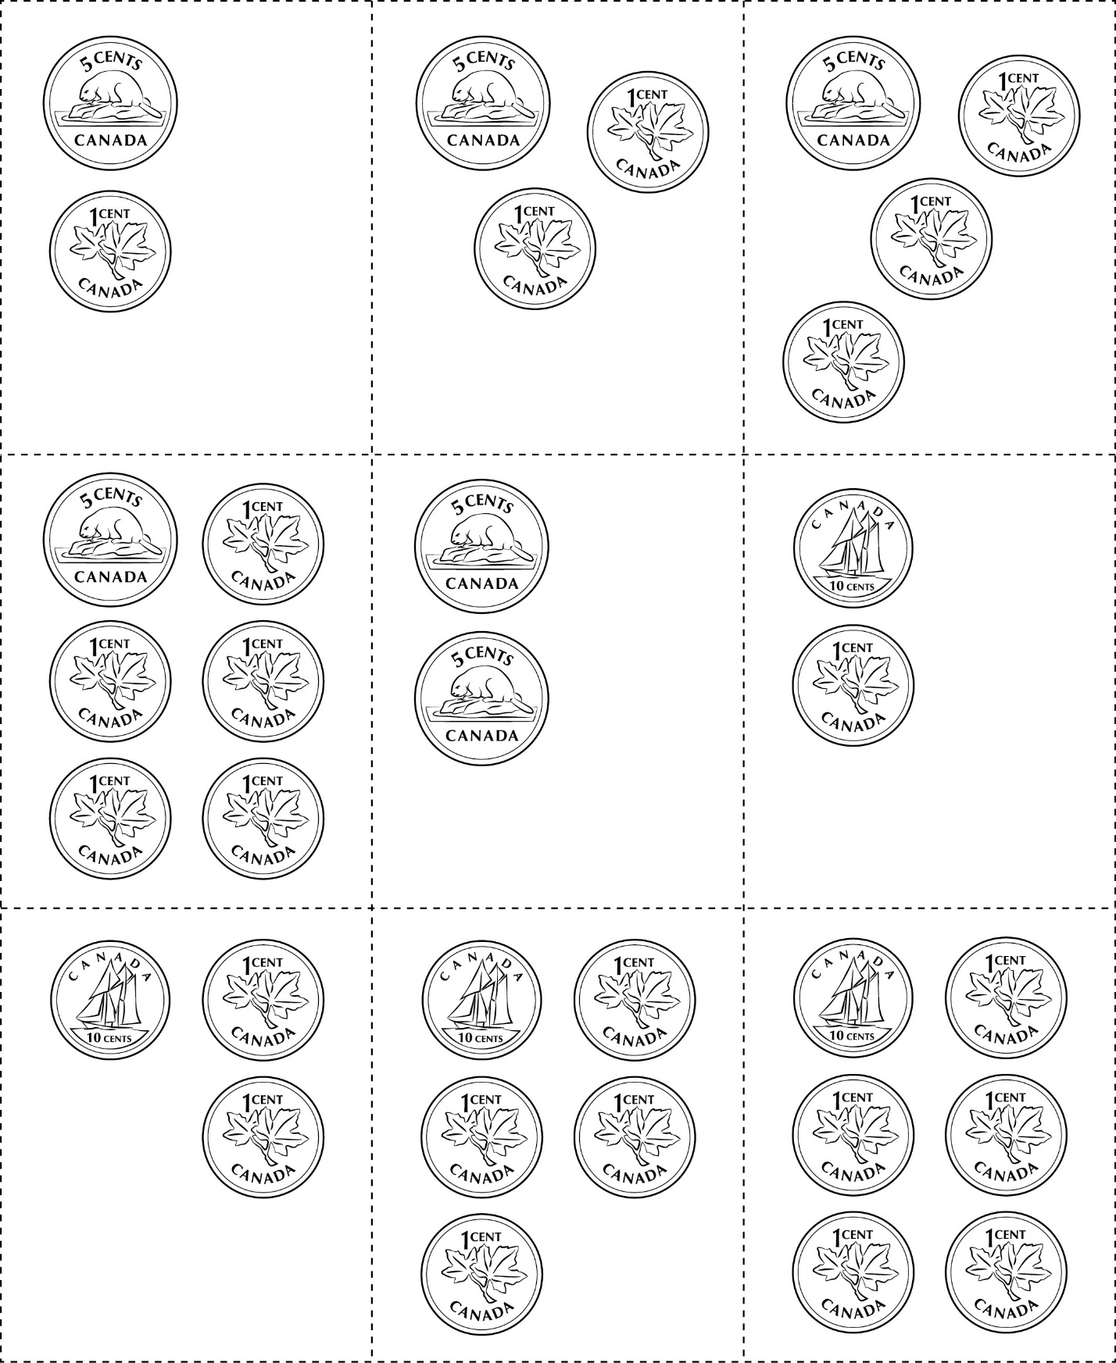



**Coin Cards**

**Master 97b**

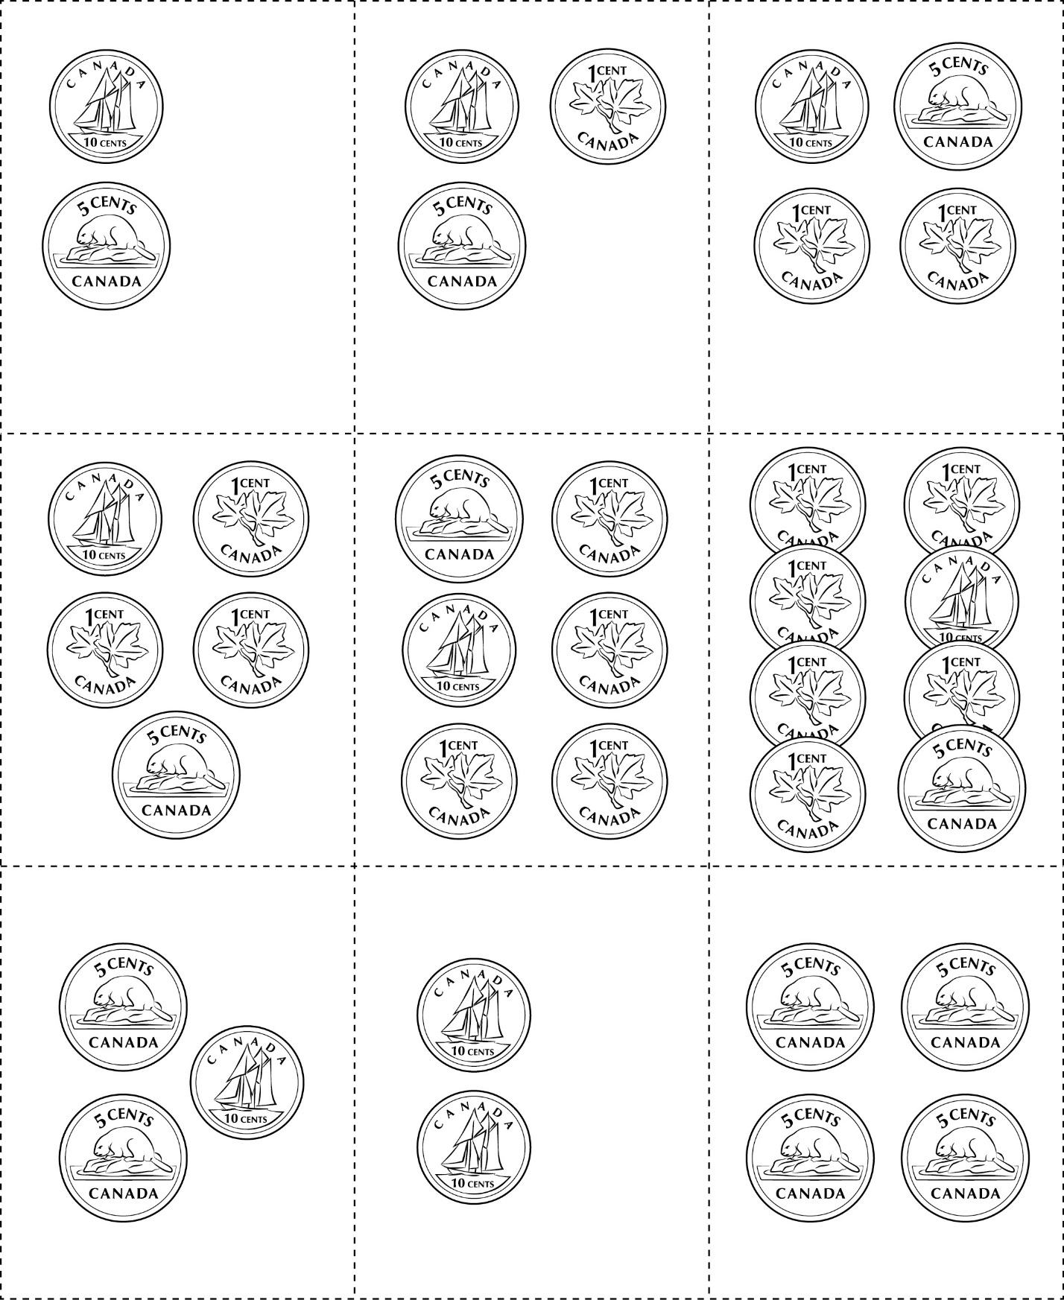



**Coin Cards**

**Master 97c**

(for Extension)

