Conceptual Understanding of Addition Behaviours/Strategies
Student does not say one number word for each counter counted, or says number word in between “touches.” | 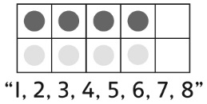  For doubles of 1–5, student uses one ten-frame and counts all the counters. | 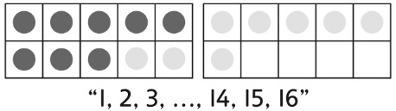  Student uses 2 ten-frames, fills one to “make 10,” then counts from 1. | 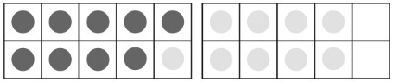  For doubles of 6–10, student uses 2 ten-frames and counts on by 1s from 10.
Observations/Documentation
Finding Doubles Behaviours/Strategies
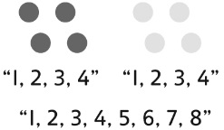  Student counts three times to determine the double. | For doubles of 6–10, student counts on from the number in the first set to determine the double.  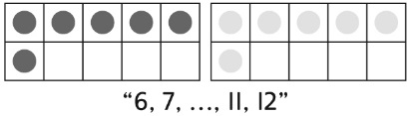 | Student successfully uses counters, with or without ten-frames, to determine the doubles of numbers  1–10. | Student knows the doubles of numbers 1–10 without using counters.
Observations/Documentation

