**Math Problem Cards**

**Master 76a**

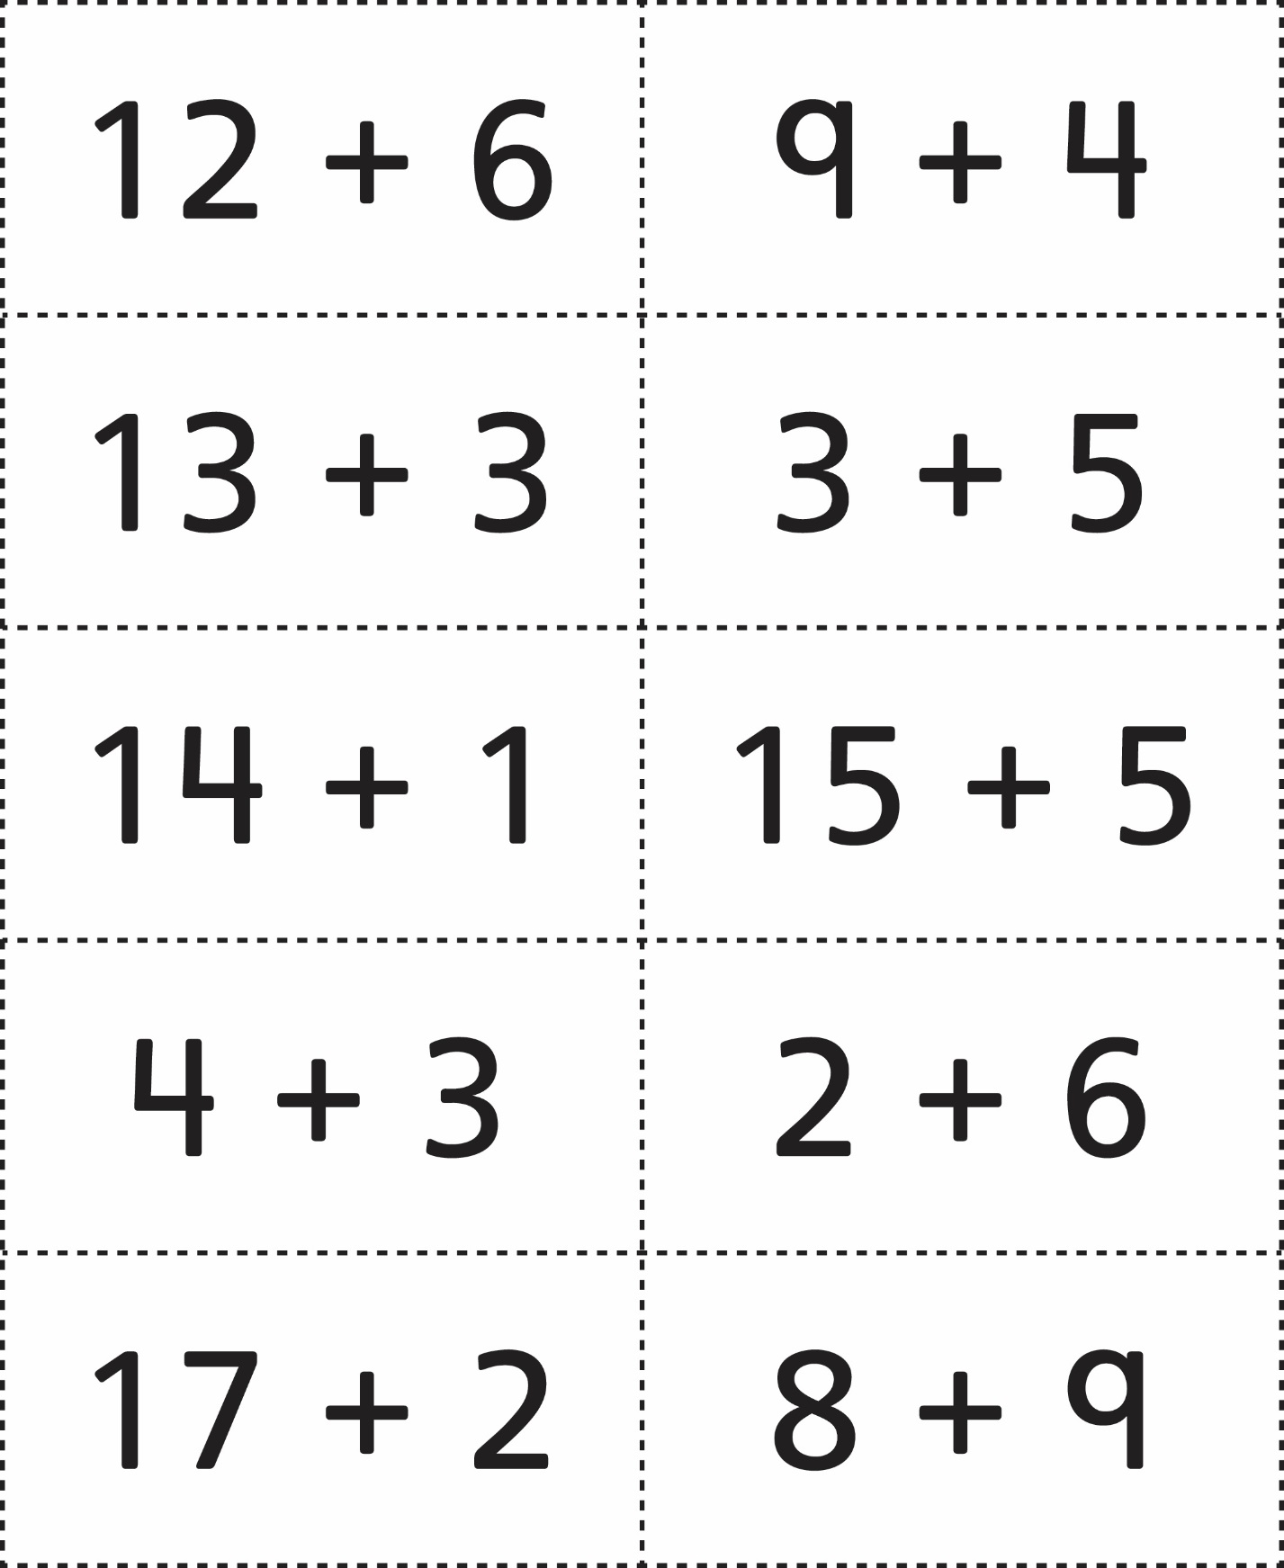



**Math Problem Cards**

**Master 76b**

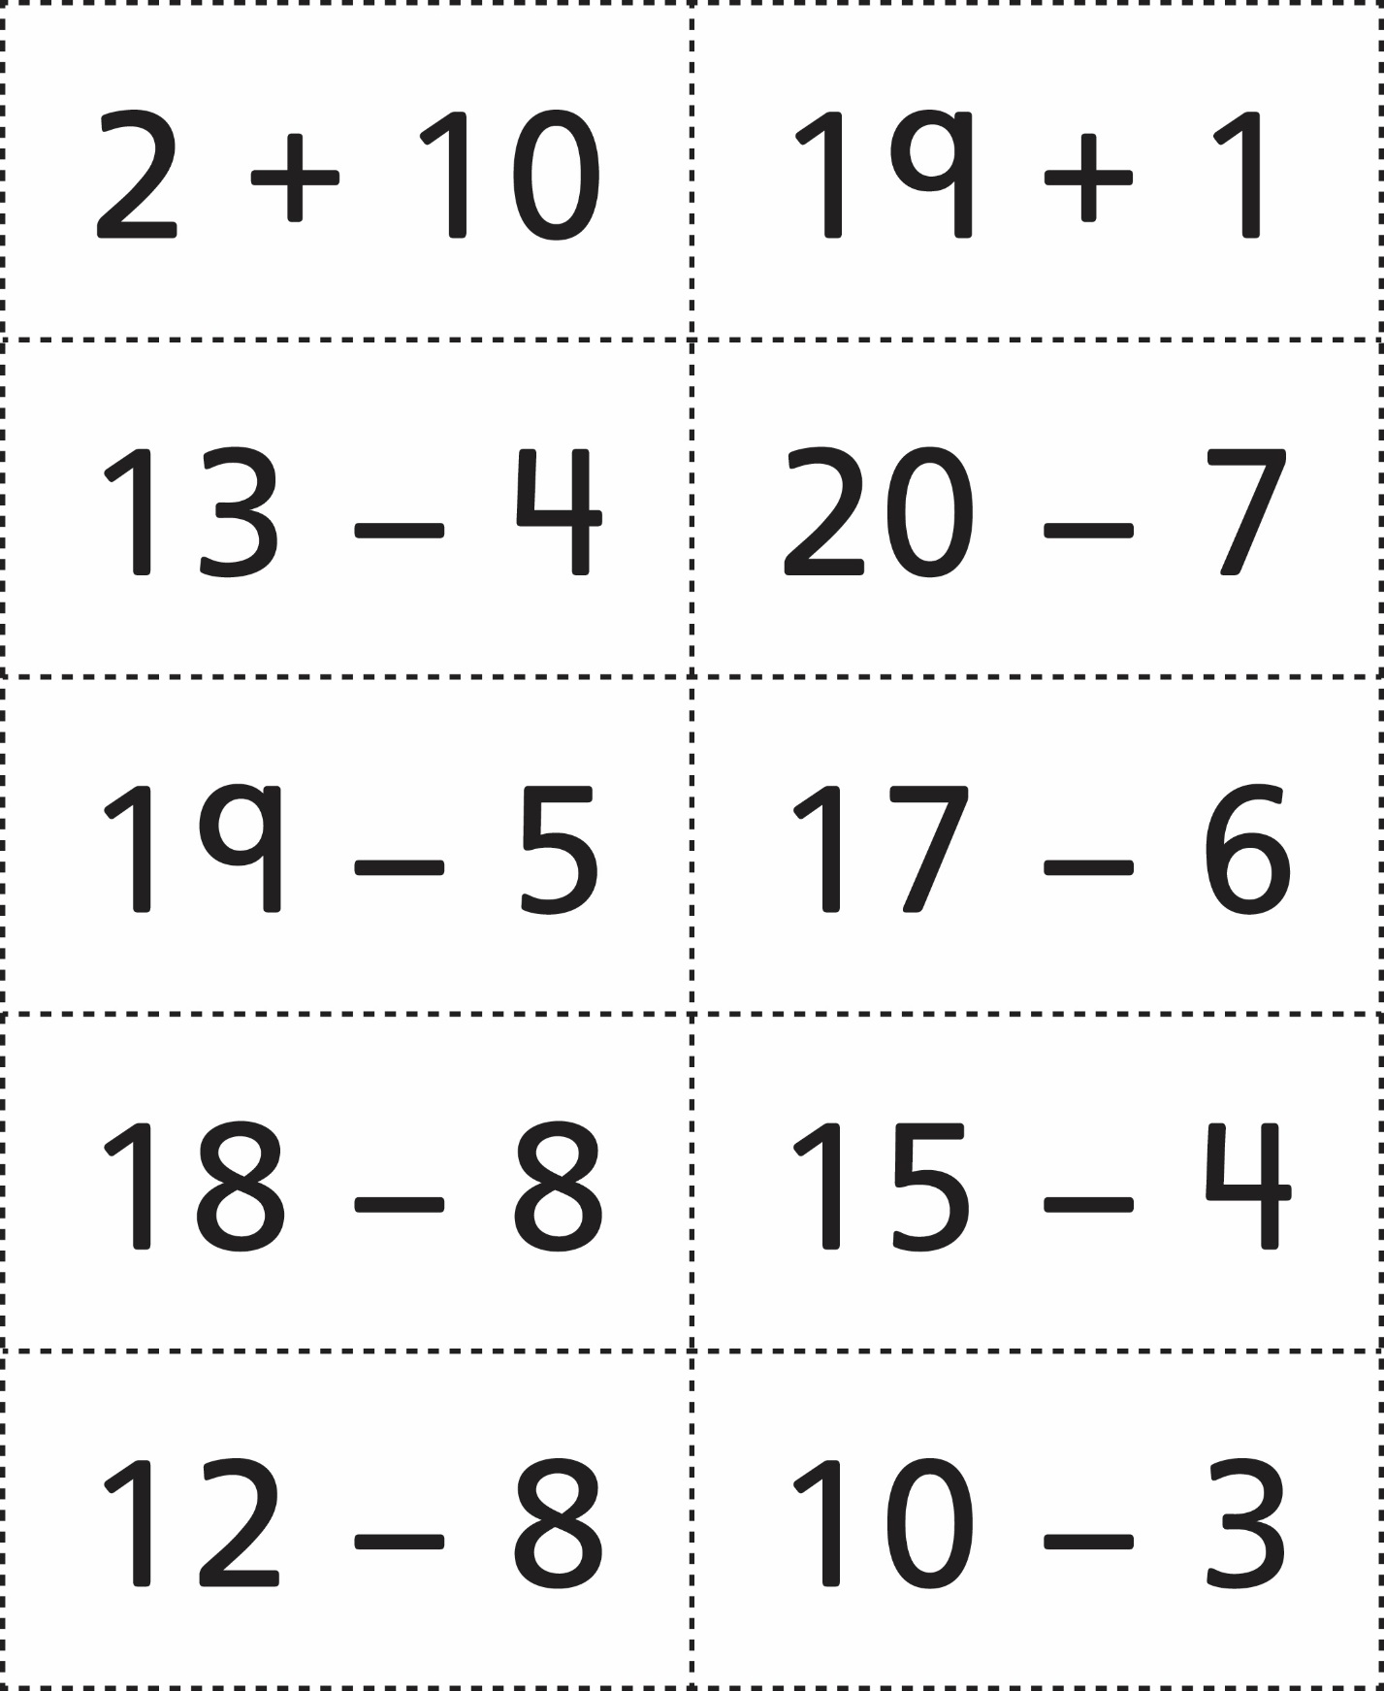



**Math Problem Cards**

**Master 76c**

