Adding and Subtracting Numbers to 20 Behaviours/Strategies
Student uses ten-frames and counters to add and subtract with quantities to 20.  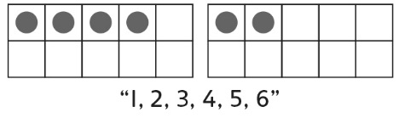 | Student counts on or back to add and subtract with quantities to 20.  7 + 9  “7” “8, 9, 10, …, 14, 15, 16” | 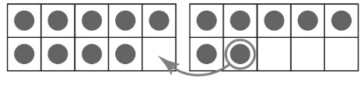  Student uses ten-frames and counters to make 10 when adding and subtracting with quantities to 20. | 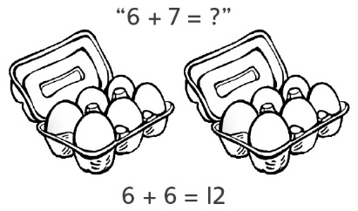  Student refers to doubles pictures when extending known sums to add and subtract with quantities to 20.
Observations/Documentation
Student uses the same strategy in every situation when adding and subtracting with quantities to 20.  “I like to count on!” | Student fluently adds with quantities to 20, but counts back by 1s to subtract.  11 – 5 = ?  “10, 9, 8, 7, 6” | Student adds and subtracts with quantities to 20 and extends known sums and differences to solve other equations, but struggles to explain thinking. | Student fluently adds and subtracts with quantities to 20, extends known sums and differences to solve other equations, and explains thinking.
Observations/Documentation

