Conceptual Understanding of Subtraction Behaviours/Strategies
Student has difficulty keeping track of the number of cubes removed.  “1, 2, 3, 4.  Did I remove 3?” | Student mixes up the number sequence when counting back.  “19, 18, 16, 14, 15” | Student recounts the cubes in the tower before removing cubes (does not trust the count in between rolls). | Student counts backward fluently and keeps track of the number of cubes with ease.
Observations/Documentation
Subtracting Numbers Behaviours/Strategies
Student counts from 1 to remove cubes from the tower, then counts the cubes left in the tower from 1. | 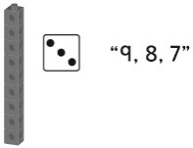  When counting back, student begins the count with the number of cubes in the tower. | 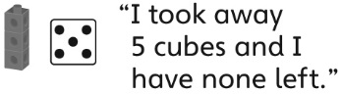  Student removes more cubes from the tower than are in the tower and says there are no cubes left. | Student subtracts cubes with ease and uses math language to describe her or his actions.
Observations/Documentation

