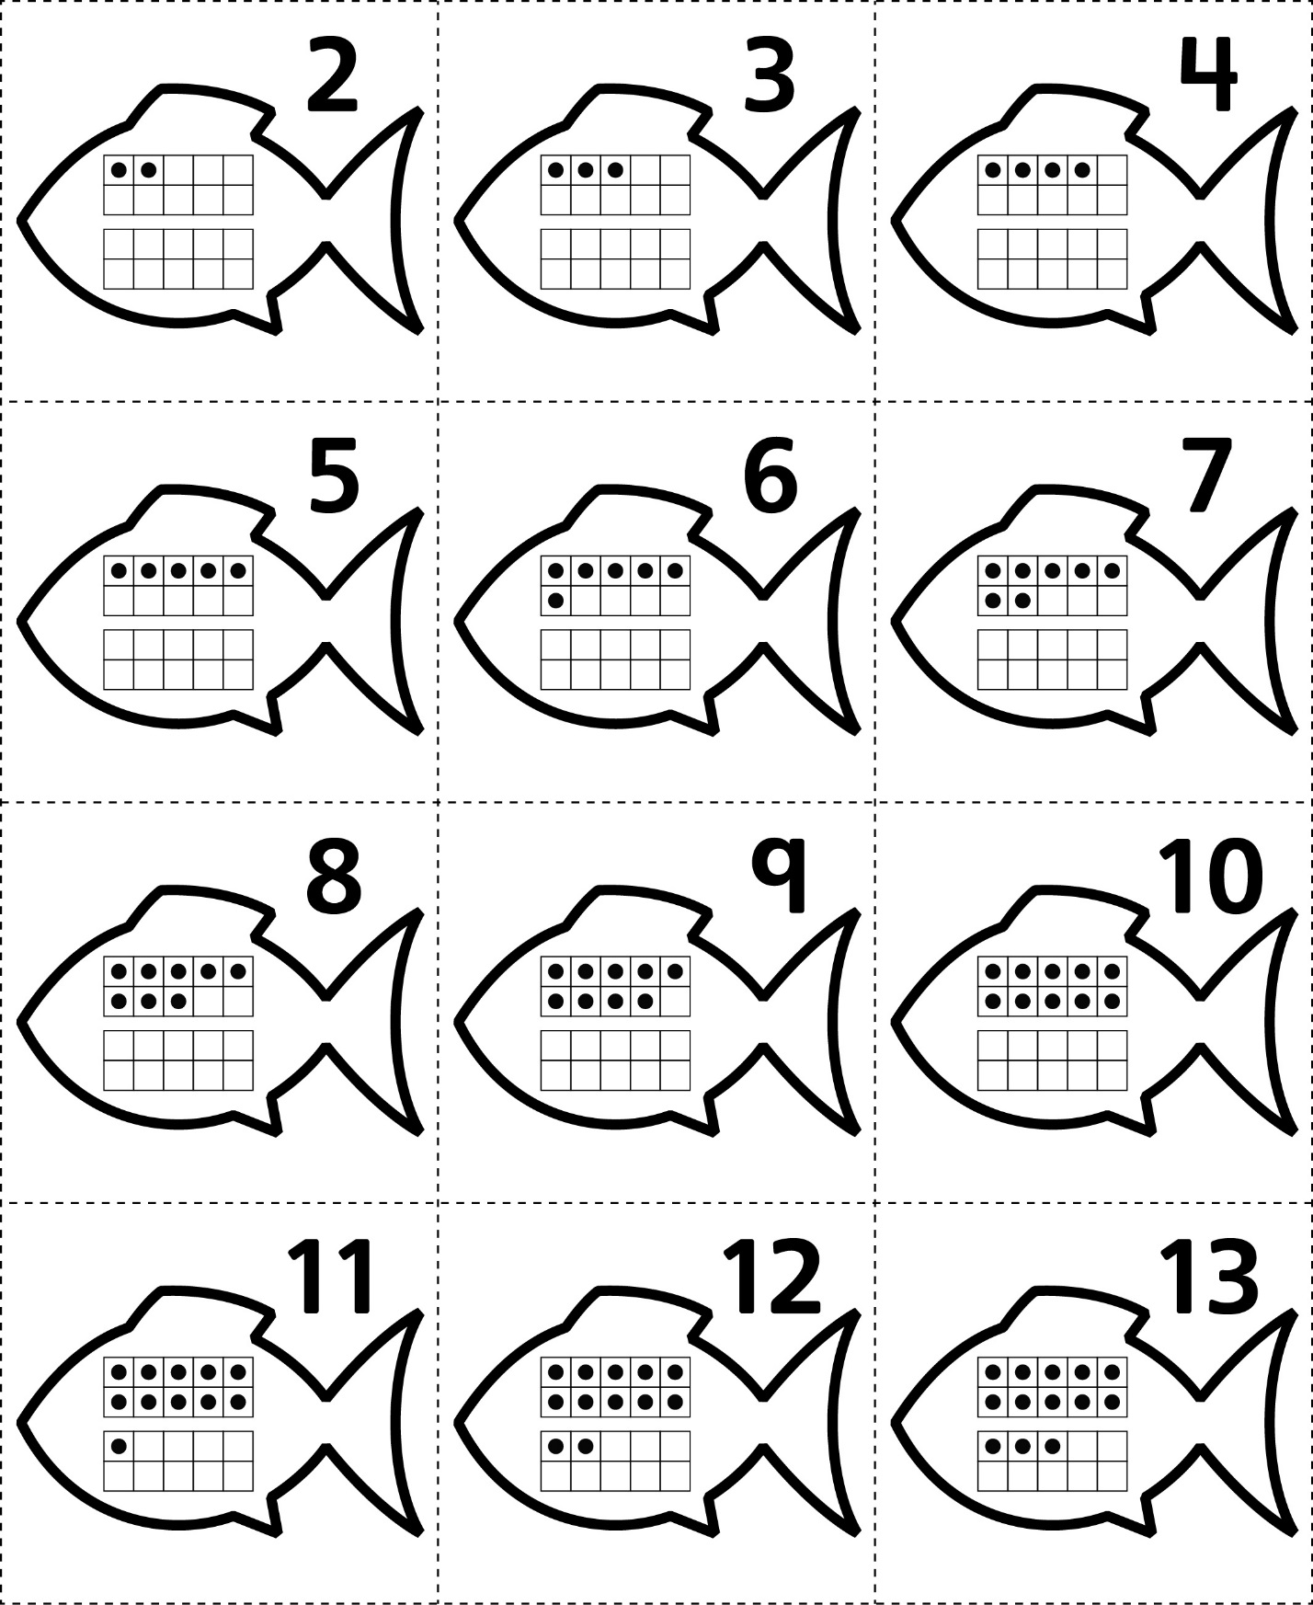**Answer Cards**

**Master 67a**

**Answer Cards**

**Master 67b**

