Recalling Complements of 10 Behaviours/Strategies
Student says numbers randomly and cannot find complements of 10.  “4 seeds and 4 seeds” | Student finds complements of 10 by counting on with fingers.  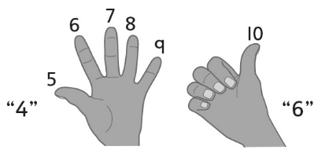 | Student finds complements of 10 by visualizing a ten-frame.  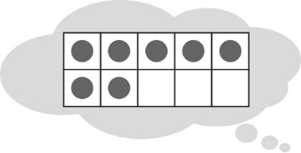
Observations/Documentation
Student recalls many complements of 10, but struggles with 0.  “I have 0 seeds. I don’t know how many  more are needed.” | Student recalls complements of 10, but does not realize that the order of the numbers does not matter (e.g., 7 + 3 and 3 + 7 are the same). | Student fluently recalls complements of 10.
Observations/Documentation

